Computer
A computer is an electronic machine that takes data as its input, processes the data and gives the information to the user as its output. The word computer is derived from Latin word compute which means calculate.

Data:
Data is the collection of raw facts and figures e.g.
Text (Alphabets, special characters, Numbers etc.), Images, Sound etc.

Information:
Information is the processed form of data, or we can say that it is the useful work done by the computer for its user.

Processing:
The conversion of data into information by applying different types of calculations is called processing

Input:
It is the data we give to the computer

Output:
It is the useful information given to the user

Storage:
It is the place inside the computer, where data is kept temporarily or permanently. We can write into and read from the storage

USERS:
Computer operators’ are called users

Number system
Any system for representing numbers is called number system.
There are four number systems.
(1) Binary Number System
(2) Octal Number System
(3) Decimal Number System
(4) Hexadecimal Number System

(1) Binary Number System:
A base-2 number system in values are expressed as combinations of two digits, 0 and 1 is called binary number system. OR
In mathematics and computer science, the binary number system, or base-2 numeral system, represents numeric values using two symbols: typically 0 and 1. Computer knows just binary numbers and not the alphabets or numbers we press. OR
Computer doesn’t understand our language and we don’t understand computer language computer just understand binary numbers and there is a main process which calculates our language into binary language and then computer understand
Binary numbers are just {0 and 1}

(2) Octal Number System:
A base-8 number system represented by the digit 0 through 7 is called octal number system.

(3) Decimal Number System:
A base-10 number system represented by the digit 0 through 9 is called decimal number system.

(4) Hexadecimal Number System:
A base-16 number system represented by the digit 0 through 9 and the uppercase or lowercase letters a (equivalent to decimal 10) through F (equivalent to decimal 15) is called hexadecimal number system.

STORAGE UNITS / MEMORY UNITS
01010101

Byte
A group of eight (8) bits is called one Byte OR
A group of two (2) nibbles is called one Byte.
1Byte = 8 bits
1 Byte = 2 Nibbles

Bit
A smallest unit of data is called bit.
A bit can be 0 or 1.

Nibble
A group of four (4) bits is called one nibble OR
The half of one Byte is called one nibble.
1 Nibble = 4 bits
1 Nibble = 1/2 Byte
1024 byte = 1 kB
1024 KB = 1 MB Mega byte
1024 MB = 1 GB giga byte
1024 GB = 1 TB tera byte

Components of a Computer:

There are 2 major components of a computer
Computer
Software

Hardware

Hardware:
The physically existing components of the computer are called hardware, or we can say that the tangible parts of the computers are hardware.

Software:
Software is the set of Instructions/Programs that are used to operate the computer. Or
All un-touchable parts of a computer system are called software.
For example MS Windows, MS DOS, Linux, MS office, Corel draw, inpage (Urdu) etc.
There are two types (categories) of software.
(a) System Software
(b) Application Software

(a) System Software:
Those software, which can fulfill the requirements of a computer system are called system software.
For example MS DOS, MS Windows, Linux etc.

MS (Microsoft)
MS Stands for Microsoft which a company of producing software like MS Windows, MS Office and others, Bill Gates is the owner of Microsoft.

Operating System (OS)
Operating system is a program that provides a user interface, controls system resources and permits the execution of other programs.

MS Windows
A single user/Multitasking operating system, which is used for the operating of computer system and application software in graphic user interface (GUI), is called windows.

Desktop
The background of display screen of computer is called desktop.

Taskbar
Taskbar is a horizontal bar at the bottom of display screen that shows which program is currently running.

Title bar
Title bar is a horizontal bar at the top of window that shows the title of the window (Program).

Status bar
Status bar is a horizontal bar at the button of the window that shows additional information about the running program.

Scroll bar
Scroll bar is a horizontal/vertical bar at the bottom or left/right of the window which is used for scrolling of specific pages.

Menu bar
Menu bar is a horizontal bar below the title bar, which is consists of various menus.

Menu
A list of commands (choice) is called menu.

Icons
The graphical objects on the screen that are the shortcut way of accessing a specific program, folder and files is called icon.
There are two kinds of icons.
1 Master/system icons
2 Normal/software icons
Master/system icons like My Computer, My documents, Recycle bin and
Normal/software icons like other icons and it always comes in left corner of monitor.

Start button
Which is in the left corner of monitor, when we click so that is called start menu.

Clock area
Which is in the right side corner of monitor, just like watch, when we click right on

Pointer
A small object (arrow) on the screen, which is used for selecting text, accessing menus and moving files or folders is called pointer.

File
A collection of related data that has been given a specific name is called file.

Folder
A tool for organizing data when stored on a disk is called folder.

Notepad
Notepad is a basic text formatting program, which is used for creating and editing text files.OR
Notepad is a simple text formatting program, which is used for typing letters, applications and notes.

WordPad
WordPad is a complex text formatting program, which is used for creating and editing text documents. OR
WordPad is a complex text formatting program, which is used for typing letters, applications, notes and many more.

MS Paint
Paint is a simple graphical program, which is used for creating and editing drawings (photos).

Control panel:
- ACCESSIBILITY OPTIONS: It is used to adjust the computer settings for vision, hearing, and mobility.
- FONTS: It is for adding, changing and managing fonts on the system.
- Game controllers. It is used to add or remove and configure game controller hard ware such as joysticks and game pads.
- Scanners and cameras. It is used to add or remove and configure scanners and cameras.
- Speech. It is used to set or change settings for text to speech and for speech pronunciation (IF IT WAS INSTALL IN YOUR COMPUTER). ;
- Display. It is used to change the appearance of the desktop, such as the background, screen saver, colors, font sizes, screen resolution.
- Sound & audio. It is for changing the sound scheme for the computer, or configures the setting for the speakers and recording devices.
- User accounts. It is used for changing user account settings and passwords for people who share this system.
- Internet options. It is used to configure the Internet display and connection settings.
- Phone & modem. It is used to configure the telephone dialing rules and modem settings
- Network. It is used for connecting to other computers, networks, and Internet.
- Regional settings. It is used to customize settings for the display of languages, numbers, times, and dates.
- Keyboard. It is used for customizing or setting the keyboard, for example the cursor blink rate and the character
- Mouse. It is for editing or customizing the mouse settings like the button configuration, double click speed, mouse pointers and motion speed.
- Programs and features. It is for installing or removing programs and windows components.
- Add hard ware. It is used to install and assistance hard ware.
- Scheduled tasks. It is used to schedule or list the computer tasks to run the programs automatically.
- System inf. it is to show or display the information about the computer system, and alter settings for hard ware, performance and automatic updates.
- Date & time. It is for setting or editing the date, time & time zone for the computer.
- Printers. It is for showing or displaying the installed printers & faxes printers and supports us to add a new one.

- Task bar & start menu. It is used for customizing or editing the start menu and the task bar like the types of items to be displayed and how they should appear.

Run: it is used to run or open a document, folder, program or a web page.

Find: It is used to find or search the data such as files, picture etc.

RECYCLE BIN. It is used for adding the deleted files which we can restore them by help of recycle bin.

(b) Application Software:
Those software, which can fulfill the requirements of a user are called Application software.
For example MS offices, Corel draw, in page (Urdu) etc.

MICROSOFT OFFICE (OR) MS-OFFICE
A group of programs, which is used in office for documentation, calculation, database, presentation and many more, is called Microsoft office. Or
MS-Office is a software suit by Microsoft. It consists of several applications like Word, Excel, and PowerPoint etc. It is used for office purposes and is professionally used in business-line of modern era and also has a billion users worldwide.

History:
- Developers: Microsoft
- Initial Release: November 19, 1990,22 years ago
- Latest Release: Microsoft Office 2013
- Written in: C++
- Operating System: Windows
- Available In: 35 Languages
- Type: Office Suite
- License: Trail ware, Retail, Volume LC, SaaS
- Website: Office.microsoft.com

Why it is Necessary to learn MS-Office:
MS-Office is a suite which is having all the necessary and important applications to learn and to use for business and also industrial use. It’s a collection for calculating to graphics need and even much more to work with and fulfill the need, In other words it’s a revolution in accounting and banking works.

Most used MS-Office Suites:
- 2000 2. 2003 3.2004 4. 2007 5.2010 6. 2013

Microsoft Word
Microsoft word is a word processing program, which is used for creating, editing, and viewing, formatting, storing, retrieving and printing documents.
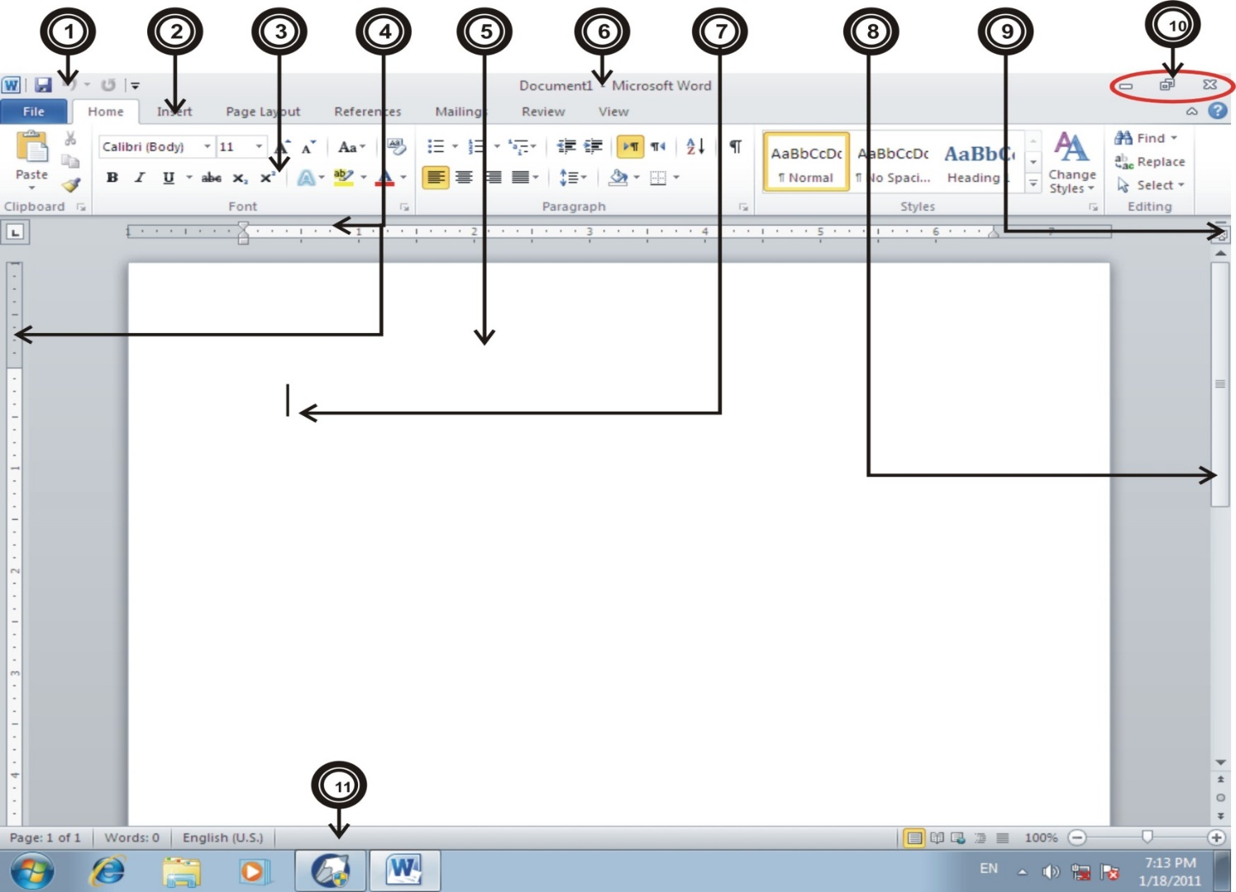


- Quick Access Toolbar
- Tabs
- Ribbon
- Rulers
- Page/Documentation Area
- Title Bar/Name of Doc…
- Cursor/Insertion Point
- Vertical Scrollbar
- Show/Hide Rulers
- Caption Buttons
- Status Bar

INTERFACE

Quick Access Toolbar:
The Quick Access Toolbar is a customizable toolbar. It is used to easily Access any Command which you most used in Documentation…
It remains visible, no matter which tab is currently displayed. Because the Quick Access Toolbar is always visible, you can store your most used commands and have them always visible…
E.g.: You used 10 Commands every time so you have to Manage those Commands in Quick Access toolbar so then you have not to switch between Tabs…
Note: - By Default we have 3 Commands on Quick Access toolbar (Save, Undo & Redo)…

Ribbon:
As we all know that in old versions of MS-Office, we used Menu bar to control all the “In” and “Out” Operations; Exactly in MS-Office 2010 for same Purpose we use “Ribbon”…
Note: - Ribbon just used for “IN” Operations…
Microsoft Introduced the Ribbon in Office 2007 to make working in documents easier, Relaxed & Stress free…
Ribbon is composed of Seven Permanent Tabs labeled (Home, Insert, Page Layout, References, Mailings, Review and View) and there are also some Additional Tabs labeled (Developer, Design, Layout & Format etc)…
Note: - All the Tabs in the Ribbon are Customizable and we also can make Tabs by own & we have fully control on customization…

Tabs:
As we know that in old versions, there were Menus on Menu bar for Specific Operations; here we have Tabs instead of Menus…

Toolbars:
Under every Tab, we have different Commands; So these all commands are aligned in the Shape of Toolbars…

Groups:
Each Toolbar is fragmented into Rectangular Groups of related commands…
E.g.: In “Home Tab” there is a Group named Clipboard; So all the Commands for (Cut, Copy & Paste) operations are assembled in that Specific Group…

What are “In” and “OUT” Operations?
In: - Those Commands which we used for the Preparation of a Document are called “In” commands…
All the commands on the (Home, Insert, Page Layout, References, Mailings, Review, and View etc) tabs of the Ribbon are commands that we use when we work in the document. Microsoft calls these commands the “In” commands…

Out:-Those Commands which we used after Preparation of a Document are called “Out” commands. E.g. (Save, Print & E-mail etc)…
All the Commands on the File Menu/Tab are not for working in the Document, we use these commands after finishing the document when we are ready to do something with it…

Rulers:
Each document window has its own rulers (Horizontal & Vertical) that provides information about TAB settings, Paragraph INDENTATION and MARGINS…

Page Area:
It defines that Documentation / Working area where we can write any text on the page…

Title Bar:
It defines the Name of the Current Document...

Cursor:
It is the Insertion Point where we going to write / remove any character or word; It is used to Focus on a Specific Area of the Page…

Scrollbars:
Placed at the right and bottom borders of the document window scroll bars Facilitate Moving around a Document using the mouse by dragging the scroll box along the scroll…

Show/Hide Rulers:
This small button is used to show or hide both Rulers (Horizontal & Vertical) on the Document window…

Caption Buttons:
There are 3 Buttons in that Group; (Minimize, Maximize & Close) which are used to control the Structure of the document window…

Status Bar:
Located at the bottom of the application window the status bar displays status or information and tracks on your current position in a document pages and number of total pages etc…
There is a group for View Layouts and also a Slider to Increase or decrease Zoom level of the current document…

Mini Toolbar:
It is used for Quick Formatting of Text and Paragraph after Selecting text or whole paragraph…

FILE TAB
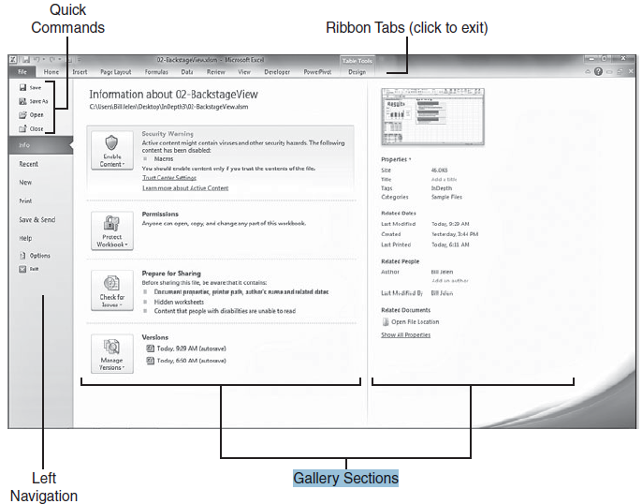
When we open the File Tab in MS-Word 2010, there is something to shock because it takes up 100% of our screen real estate. This New Feature is called the Backstage View…

Backstage is split into three sections; The Narrow left navigation panel and two wider sections that provide information…
Note: - We can use “Esc” key to close backstage view and return to document…

Save (CTRL+S): It is used to save Current Document…
Note: - There is a Facility in MS-Word 2010 to save file in New Version (docx) or in an old version 1997-2003 (doc)…
Note: - We can save our file in PDF (Portable Document Format) in MS-Word 2010, which was not possible in old versions of MS-Word…

Save As (F12): It is used for taking a copy of current Document. That Document can be saved with a different name, Type & Location…
Open (CTRL+O): It is used to open any saved Document…
Note: - When we open an old version (doc) word files in MS-Word 2010; we will see a Message along with the document name on the title bar “Compatibility mode”….

How can we convert an older version file (doc) in new version (docx)?
If we want to convert an older version file (doc) in New Version (docx) so it is so simple. File Tab info Click on “Convert” button…
Close (CTRL+W): It is used to close the Current Document…
Info (ALT+F+I): It is used to View/Edit all the Information about the current Document…
Recent (ALT+F+R): There are Two Sections in Recent Option
- Recent Documents
- Recent Places
Recent Documents: - These are the short cuts of those word files which have used recently and these can be opened easily by just single clicking…
Recent Places: - These are the short cuts of those Locations from where we have opened word files recently and we easily can reopen files from those specific locations by just single clicking…
Note: - Recent Documents list can show up to 50 Documents at a time…
Note: - We can add the Recent File list to the Quick access toolbar, and it easily can be open by Keyboard Short cut (Alt+4)…

How can we clear the Recent Documents List?
If we want to clear out the Recent Documents List, So we should open (File Options Advanced Display) Now set the “Show This Number of Recent Documents” List to zero.

What is meant by “Pin” and “Unpin”?
If we notice there are “Gray Pushpins” on the both columns list with every Item. If we click one of those gray pushpins, it turns into a colored pushpin that appears to be pushed into screen. This pins an item to either the recent documents or the recent places list. When an item is pinned to the list, it stays at the top of the list, no matter how many other files we might open.

What is meant by “Quickly access this number of Recent Documents”?
It is the Second method for quickly accessing recent documents. It gives us a room to store recent documents list along the left navigation panel.
Note: - If we have Pinned items to the recent documents list, they are shown immediately after the quick commands in the left navigation panel…

What is meant by “Recover Unsaved Documents”?
Using this brand new Feature we can recover our all unsaved documents. MS-Word 2010 can automatically save copies of our document every one Minute.
Note: - For ease, first of all we have to set time for Auto Recover information every 1 min.
Word Option Save Save auto recover information every 1 minute…

New (CTRL+N): It is used for the setup of New Document…
Document can be a Simple Blank Document, Blog Post, Sample Template or any other Template from Office.com…
Print (CTRL+P): It is used for Printing Document on Paper and to Preview Document before printing…
Note: - Short cut key for Print Preview command is (CTRL+F2)…

Save & Send (ALT+F+D): It is used to save current Document with a different Format, and to send document via E-mail etc…
Help (ALT+F+H): It is used to get help about Microsoft Word, and to view the MS-Office Activation information etc…
Options (ALT+F+T): It is used to Control all the Application’s Options…
Every Command which we want to Modify, we can that in Options…
Note: - It is also called “Word Options”…

Exit (ALT+F4): It is used to Exit the Current Application (MS-Word)…

HOME TAB
Home Tab is the First tab of “In Operations”, and it is arranged by the most common and useful commands used for text and paragraph editing. There are about 5 Rectangular Groups by Default named (Clipboard, Font, Paragraph, Styles & Editing)…

CLIPBOARD: This Group is designed for cut, copy and paste operations in MS-Word…
Cut (CTRL+X): It is used to cut the selected Text or Object…
Copy (CTRL+C): It is used to Copy the selected Text or Object…
Paste (CTRL+V): After Cut/Copy Command we use Paste Option, To Paste Selection to the insertion point…
Note: - After Cut or Copy Command Paste is Necessary…
Format Painter: It is used to Copy just text formatting from one place and applies it to another place…
Paste Special (ALT+H+V+S): It is used to Paste any Selection Something Special…
Like as an Object, Formatted, Unformatted and as a Picture etc…

Clipboard (ALT+H+F+O): It is used for “Paste” Target, In Simple Cut/Copy Paste There we could Cut/Copy just one Selection/Objects and Then we Paste That, But in Clipboard Here we can Cut/Copy Multiple Selections and Then which one we want to Paste we will Just click on that in the Clipboard Pane…

FONT (CTRL +D): This Group is designed for just Text Formatting…
Font Style/Face (CTRL+SHIFT+F): It is used to change font Face / Style of selected text…
Note: - We can install additional fonts in computer from any other source…
Font Size (CTRL+SHIFT+P): It is used to change selected text’s size…
Grow Font (CTRL+SHIFT+>): It is used to Increase font size at once…
Shrink Font (CTRL+SHIFT+<): It is used to Decrease font size at once…

Note: - Font size also can be increase and decrease by using following keyboard keystrokes.
Increase : Ctrl + ]
Decrease : Ctrl + [
Change Case (SHIFT+F3): It is used to Change the Alphabet Case in order to (Sentence case, lower case, UPPER CASE, Title Case & tOGGLE cASE)…
Clear Formatting (CTRL+SPACE): It is used to clear all formats from selected text and to convert that text into “Unformatted”…
Bold (CTRL+B): It is used to Bold (Gallant) selected Text…
Italic (CTRL+I): It is used to Italic (Oblique) selected Text…
Underline (CTRL+U): It is used to Underline selected text…
Note: - There are some underline options instead of single underline which are following.
Double : Ctrl + Shift + D
Word Underline : Ctrl + Shift + W
Strikethrough (ALT+H+4): It is used to Strikethrough selected text…
Sub & Super Scripts (ALT+H+5/6): It is used to _{Sub} or ^{Super} Script selected text…
Note: - Usually Sub & Super Scripts are used for Chemistry Formulas like: -
H₂O H₂SO⁴
Text Effects (ALT+H+F+T): It is used to apply Built-in Effects on selected Text…
Outline: - These options are used to control the Outline (Color, width and line style) of selected Text…
Shadow: - These options are used to apply Shadow on selected text and to control all the options about Shadow…
Reflection: - These options are used to Mirror Text/Echo of Selected Text…
Glow: - These options are used to apply Light or Spark Effect on Selected Text…
Note: - Usually all Text Effects are used for Headings etc which we want to show something Special in the whole document…
Highlight (ALT+H+I): It is used to Highlight/Highpoint the text; to show the text something special from other text…
Font Color (ALT+H+F+C): It is used to choose/customize a color for the selected text…
Note: - We can apply Gradient (Multiple Colors) too on selected text...

Font Dialog Launcher (CTRL+D): There are 2 Tabs in Font Dialog…
- Font
- Advanced
Font: - Using Font Tab we can apply all the text formats options which are in Font Group; But in “Font Group”, there are not complete options but in font Dialog there are complete options about text formatting like (Double Strikethrough, Small Caps and All Caps etc)…
Advanced: - These options are used for some advance formatting like (Character’s Scale, Character Spacing and Position etc)…

PARAGRAPH: This Group is designed for just Paragraph formatting…
What is Paragraph?
A Piece / Section of Text in a page; after pressing “Enter” the new line is called Paragraph…
What is Sentence?
A Piece / Section of Text in a Paragraph; after pressing “.” means full stop, the new word is called sentence…
What is Word?
A Piece / Section of Text in a Sentence; after pressing “Space” the new Character is called Word…
What is Character?
A Simple Alphabet in a word is called Character…

Bullets (CTRL+SHIFT+L): It is used to apply and Edit the Bullets Style (In the Form of Font, Symbol, Picture and Indentation) and to change the list level…
Numbering (1+.+Space): It is used to apply and Customize the Numbers Styles; To change the list level and to Define the Number Format…
Multilevel List (ALT+H+M): Simply these are the List Levels of bullets and numbering which also can be applied by bullets and numbering options…
Increase Indent (ALT+H+A+I): It is used just like “Tab” to increase indentation of Paragraph…
Decrease Indent (ALT+H+A+O): It is used just like “Back Space” to decrease indentation of paragraph…
Direction (ALT+H+0): These are used to switch paragraph direction to “Left” or “Right”…
Sort (ALT+H+S+O): It is used to give Sequence to the Table / Paragraph’s Data in the shape of…
Ascending : A to Z or 1 to 100

Descending : Z to A or 100 to 1
Note: - In Word 2010 we have a Facility to Sort Paragraph’s Data too…
Non Printing Characters (ALT+H+8): It is used to Show / Hide those characters which will not be Printed (Non Printed Characters)…
Paragraph Alignment: These options are used for Paragraph Alignment that from where our current paragraph should be starts?
Alignment Type | Keyboard Acceleration
Left | Ctrl + L
Center | Ctrl + E
Right | Ctrl + R
Justify | Ctrl + J

Line Spacing (ALT+H+K): These options are used for spacing between lines of current paragraph…
Spacing Type | Keyboard Acceleration
1.0 | Ctrl + 1
1.5 | Ctrl + 5
2.0 | Ctrl + 2

Shading (ALT+H+H): It is used to apply and modify Shading (Background Color) for the Selected Text / Paragraph in Document…
Borders (ALT+H+H): These all options are used to control borders and there are also some extra options like (Horizontal Line, Draw Table & View Gridlines) which are not related to Borders…
Horizontal Line: - It is used to insert a Horizontal line to the current position; It can be used to add formats to the document…
Draw Table: - It is used to draw table just like using Pencil; we can add columns and rows to that table too…
View Gridlines: - After Deleting outside Borders from any table this option can Show / Hide those deleted outside borders which are called “Gridlines”…
Borders & Shading (ALT+H+H): There are 3 Tabs in Borders & Shading…
- Borders
- Page Border
- Shading
Borders: - It is used to apply and adjust Borders for Selected (Text, Paragraph, Table and Picture)…
Page Borders: - It is used to apply and adjust Borders for the Whole Pages in Document…

Note: - We can apply any Built-in Style called “Art” on the Page Borders…
Shading: - It is used to apply and modify Shading (Background Color) for the Selected Text / Paragraph in Document…
Note: - Text Background can be a Color or a Pattern…
Paragraph Dialog Launcher (ALT+H+P+G): Here are some extra options which were not presented in Paragraph Group…

STYLES: This Group is designed for Text Styles which can easily be applied to the selection…
Paragraph Styles (ALT+H+L): It is used to apply and Edit the Built-in Styles of Paragraph Formatting and to create new Styles…

How can we easily Edit any Built-in Style?
Right Click on any Predefined style Click on Modify Now we have all the options to edit any style…

How can we easily Add a style?
Select the text which we want to add for Style Open Paragraph Styles Combo Box Click on “Save selection as a new Quick style” Assign name for that Style & then click on “OK” button…

How can we select all the Instances of a style?
Right Click on any style Click on “Select all instances” Now all the instances of current style will be selected…

How can we delete a style from Quick Style Gallery?
Right Click on any style Click on “Remove from Quick Style Gallery” Now that particular style will be deleted forever from gallery…
Clear Formatting: - It is used to clear all formats from selected text and to convert that text into “Unformatted”…
Note: - Same option is in Font Group named “Clear Formatting”…
Document Styles (ALT+H+G): Here are some Built-in Styles for whole Document Formatting (Style set, Colors, Fonts and Paragraph spacing)…
Styles Window Launcher (ALT+H+F+Y): All the Paragraph Styles can be edited / customized here too…
Style Inspector: - It is used to View or Check the formatting of selected Text…
Note: - It is just like “Reveal Formatting” option which was in old Versions of MS-Word…

EDITING: This Group is designed for Find, Replace, Go to and Selection reasons…

Find (CTRL+F): It is used to find any Word/Sentence in Document. This option search text by using “Navigation Pane”…
Advanced Find (ALT+H+F+D+A): It is used to find any Word/Sentence in Document using some advanced options like: - (Direction, Match case, Find whole words only, Sounds like, Find all word forms and by Formats etc)…
Go to (CTRL+G): It is used to Go/Switch to any (Page, Section, Line, Bookmark, Comment, Footnote, Endnote and Table etc)…
Replace (CTRL+H): It is used to replace any Word/Sentence in Document with another word or Sentence…
First of all we have to give the Criteria and then we have to write the Replace word/Sentence…
Note: - Replace options also have same advanced options which were in Advanced Find…
Select All (CTRL+A): It is used to Select All the Text/Objects in the Document…
Select Objects (ALT+H+S+L+O): It is used to Select Rectangular Regions of Objects…
This option just converts mouse pointer in “Arrow” shape from “Curser” shape to select objects…
Note: - Objects also can be selected using “Curser” shape mouse pointer…
Select Text with Similar Formatting (ALT+H+S+L+S): It is used to select text with similar formatting in the active document…
Selection Pane (ALT+H+S+L+P): It is used to control all the objects used in current document. It can be used to select any one object, To Show/Hide objects and to Re-order those objects in document…

Insert TAB
Insert Tab is the Second tab of “In Operations”, and it is arranged by the most common and useful commands used for insertions and Attachments. There are about 7 Rectangular Groups by Default named (Pages, Tables, Illustrations, Links, Header n Footer, Text and Symbols)…

PAGES: This Group is designed for inserting pages…

Cover Page (ALT+N+V): It is used to insert any cover page from built-in designs…

What is Cover Page?
The First Page and Last Page of any Document/Book are called Cover Page…

How can we Save a Cover Page in the Gallery?
First Design a Page for Cover Page (Arrange Pictures and Text Boxes etc) Select the contents of that page Then in Cover Page click on “Save selection to cover page gallery”…

Can we use our saved cover page in Future?
Yes, any saved design in MS-Word 2010 can be used like the Built-in Patterns; The saved design always come on the last of the list…
Note: - Any design in MS-Word 2010 which we save actually saves in Building Blocks…
Blank Page (ALT+N+N+P): It is used to insert a new blank page at the cursor position in document…
Page Break (CTRL+ENTER): It is used to Page Break at current position in document…
Note: - Difference between Blank Page and Page Break is that in Blank Page a new blank page comes at the cursor position but in Page Break just curser goes to next Page means the text after cursor position in current page shifts to next Page…

TABLES: This Group is designed for inserting different types of Tables…

For which Purpose Tables are used?
Tables are used to store data on a specific Structure…

What is Table?
The Collection of Rows and Columns which Comprises Cells, is called Table…

What is Row?
The Line which has Horizontal / Flat or Parallel Shape, is called Row…

What is Column?
The Line which has Vertical / 90 Degree Shape, is called Column…

What is Cell?
A Simple Text box or Data Box is called Cell…

How to create a simple Table?
We can make a simple table by selecting Columns and Rows which we need from table’s list box…

Insert Table (ALT+N+T+I): It is used to insert a simple blank Table at cursor position by assigning Columns and Rows Numbers…

Note: - After inserting / selecting table, Table Tools (Design & Layout Tabs) appears on the Ribbon which are the extra options for controlling Tables…

Design TAB (Table Tools)
Design Tab is not a Default Tab; it appears while editing any table. It is designed for those options which are very useful for Table’s Design. There are about 3 Rectangular Groups by Default named (Table Style Options, Table Styles & Draw Borders)…
Table style options: This Group is designed to show a column / Row something special from others…
Note: - After applying Table Style on the table then these options will be working; otherwise these are useless…
Header Row (ALT+J+T+A): This check box tells that we have Heading’s Row in current table and that Heading Row will be shown / Formatted something different from other Rows…
Total Row (ALT+J+T+T): This check box tells that we have Total’s Row in current table and that Heading Row will be shown / Formatted something different from other Rows…
First Column (ALT+J+T+M): This check box tells that we want to show / format first column something different from other Columns…
Last Column (ALT+J+T+N): This check box tells that we want to show / format last column of the table something different from other Columns…
Banded Rows / Columns (ALT+J+T+R/U): These check boxes format the table’s Columns and Rows by banding them…

Table styles: This Group is designed for applying & Controlling Table Styles…
Table Styles Gallery: Here we have built-in styles to be applied on any current table…
Shading (ALT+J+T+H): It is used to apply and modify Shading (Background Color) for the Selected / Current cells in the table…
Borders (ALT+J+T+B): These all options are used to control borders and there are also some extra options like (Horizontal Line, Draw Table & View Gridlines) which are not related to Borders…
Note: - We have discussed all these options in detail in Home Tab (Paragraph Group)…

Draw borders: This Group is designed to draw any table (just like a pencil) and to customize the border options…
Line Style / Line Weight / Pen Color: These 3 options are used to manage border’s style for that line / table which is going to be draw…
Draw Table Tool (ALT+J+T+D): This tool is used to draw table easily like using pencil. First we’ll draw outside border for that table, and then we’ll draw columns and rows
In that table…
Note: - The same “Draw Table” tool is in Insert Tab (Table Group) too…
Eraser Tool (ALT+J+T+E): This tool is used to erase / delete any outside or inside line in the current table…
Note: - After erasing outside borders from table these will be showing (but not be printed), if we want to hide those deleted outside borders in document so we have to Point out “View Gridlines” option in Layout Tab (Table Tools)…
Borders ‘n’ Shading Dialogue Launcher (ALT+J+T+O): The same option is discussed in detail in Home Tab (Paragraph Group)…

Layout TAB (Table Tools)
Layout Tab is not a Default Tab; it appears while editing any table. It is designed for those options which are useful for Table’s Layout. There are about 6 Rectangular Groups by Default named (Table, Rows & Columns, Merge, Cell Size, Alignment and Data)…
Table: This Group is designed for (Selecting, Show / Hide Gridlines and Table Properties) options…
Select (ALT+J+L+K): These options are used to select current Table, Column, Row or Cell in current table…
View Gridlines (ALT+J+L+T+G): After erasing outside borders from table, these will be showing (but not be printed), if we want to show / hide those deleted outside borders in document so we’ll use this option…
Table Properties (ALT+J+L+O): It is used to set Alignment of Table, Table Direction, Table Size, Row Size, Column and Cell Size etc…
Rows and columns: This Group is designed for Insertion and Deletion of Rows and Columns…
Delete (ALT+J+L+D): These options are used to delete Table / Row / Column or Cell…

Insert (ALT+J+L+A/E/L/R): These options are used to Insert Row / Column…
Insert Cell Dialogue Launcher (ALT+J+L+I): All the options in this Dialogue are used for same insertion Purposes…
Merge: This Group is designed for Combining and Splitting Cells / Table…
Merge Cells (ALT+J+L+M): It is used to Combine / Join some Selected Cells in the Form of One Cell…
Split Cells (ALT+J+L+P): It is used to divide one Cell into multiple Cells…
Split Table (ALT+J+L+Q): Split Table is used for Two Purposes…
Heading : By this Option we can get Heading line before Table…
Split : By this Option we can Split / Divide Table into Parts…
Cell size: This Group is designed for controlling the Size of Cell / Table / Row and Column…
Cell Size (ALT+J+L+H/W): It is used to set the Height and Width for current cell…
Distribute Rows (ALT+J+L+U+R): It is used to distribute the Height between all the Rows in the Table equally…
Distribute Columns (ALT+J+L+U+C): It is used to distribute the Width between all the Columns in the Table equally…
AutoFit Contents (ALT+J+L+F+C): It is used to fit the Table size on the Contents / Data of the Table…
AutoFit Window (ALT+J+L+F+W): It is used to fit the Table size on the whole Page Area…
Fixed Column Width (ALT+J+L+F+N): It is used to fix the Column’s width that the width should be remaining permanently same…
Alignment: This Group is designed for Contents Alignment in Cells…
Alignment (ALT+J+L+C+C): It is used to Align Text in the cells of the current Table…
Text Direction (ALT+J+L+G): It is used to switch the Direction of text in the table…
Cell Margins (ALT+J+L+N): It is used to set the Cell’s Internal Margin…
Data: This Group is designed for Sort and Formulas etc…
Sort (ALT+J+L+S+O): It is used to give Sequence to the Table’s Data in the shape of…

Ascending : A to Z or 1 to 100
Descending : Z to A or 100 to 1
Note: - Same “Sort” option has studied in Home Tab (Paragraph Group)…
Repeat Header Rows (ALT+J+L+J): Sometimes one Table has a large amount of Data & that Data is Over 1 Page, so the Headings of Table which we have given on First Page those Headings will not be showing on 2nd and 3rd Pages. If we want to show Headings of that Particular Table on every Page so we have to use “Repeat Header Rows” Option…
Convert to Text (ALT+J+L+V): It is used to Convert Table’s Data into Text by the Help of Tabs or any other Special Character…
Note: - Text Data (where tabs are used) can also be converted in Table; That option is in Insert Tab (Tables Group) named “Convert Text to Table”…
Formula (ALT+J+L+U+L): It is used to Add, Subtract, Multiply and Divide Values in the Table…
Note: - Formulas can be applied on Cell References too…

Draw Table (ALT+N+T+D): This option is used to draw table easily like using pencil. First we’ll draw outside border for that table, and then we’ll draw columns and rows
In that table…
Note: - The same “Draw Table” option is in Table Tools (Design Tab) too…
Convert Text to Table (ALT+N+T+V): It is used to Convert Text (where Tabs are used) into Table…
Excel Spreadsheet (ALT+N+T+X): It is used to Insert Excel Spreadsheet on current cursor position to work on…
Quick Tables (ALT+N+T+T): It is used to insert any Built-in Table from the Office Gallery like Calendar etc…
Save Selection to the Quick Tables Gallery (ALT+N+T+T+S): It is used to save the selected table in Office Quick Parts Gallery…

Illustrations: This Group is designed for inserting different types of Illustrations like (Pictures, Artworks, Diagrams, Graphics and Charts etc)…
Picture (ALT+N+P): It is used to insert Picture from Computer or any other Source…

Note: - After inserting / selecting Picture, Picture Tools (Format Tab) appears on the Ribbon which are the extra options for controlling current picture…

Format TAB (Picture Tools)
Format Tab is not a Default Tab; it appears while editing any Picture. It is designed for those options which are very useful for Picture’s Design. There are about 4 Rectangular Groups by Default named (Adjust, Picture Styles, Arrange & Styles)…
Note: - In MS-Word 2010, we have a lot of Facilities about Picture’s editing. In old versions of MS-Word for Picture formatting we had to switch to Adobe Photoshop or any other Roster Graphical Application but in this brand new version of Office, we have much better Facilities for Picture’s Styles…
Adjust: This Group is designed to adjust the colors of current picture…
Remove Background (ALT+J+E): It is used to Remove unwanted / undesirable portions of selected picture…
Corrections (ALT+J+R): It is used to Adjust the (Sharpness & Softness and Brightness & Contrast) of selected Picture…
Color (ALT+J+I): It is used to modify the color of current picture…
Artistic Effects (ALT+J+X): It is used to modify the look of picture like a Painting or Sketch…
Change Picture (ALT+J+G): It is used to Replace current Picture with another picture, The Formats and Size will be same of new Replaced picture as a previous picture…
Reset Picture (ALT+J+Q): It is used to Discard all the Formats and Size Editing of current Picture…
Picture Styles: This Group is designed for applying & Controlling Picture Styles…
Picture Styles Gallery: Here we have built-in styles to be applied on any current Picture…
Picture Border (ALT+J+S+O): These options are used to control the Outline / Border (Color, width and line style) of selected Picture…
Picture Effects (ALT+J+F): These options are used to Apply / Control the Effects like (Shadow and Reflection) for the selected Image…
Presets: - Here are some Predefined / Customized Effects (Shadow, Reflection, Glow and Bevel etc) to be applied on current Pic…
Shadow: - These options are used to apply Shadow on selected Picture and to control all the options about Shadow…
Reflection: - These options are used to apply Mirror / Echo Effect on selected Picture…

Glow: - These options are used to apply Light or Spark Effect on Selected Picture…
Soft Edges: - These options are used to Soft the Edges of current Pic…
Bevel: - These options are used to apply / control “Emboss” and “Engrave” effects on selected Image…
3-D Rotation: - These options are used to choose a Rotate Style for selected picture and to Edit that Rotation Angle…
Picture Layout (ALT+J+C): It is used to change current picture’s layout with another SmartArt Layout…
Format Picture Dialogue Launcher (ALT+J+O): All these options in this specific Dialogue are used to edit the applied Effects…
Arrange: This Group is designed for Picture’s Position and Alignment…
Note: - Whole Arrange Group is in “Page Layout Tab” too…
Position (ALT+J+P+O): It is used to specify the position of current picture on page…
Wrap Text (ALT+J+T+W): It is used to put any picture / Object (In line with Text, Square, Tight, Behind Text, In front of Text, Top & Bottom, Through and Edit Wrap Points)…
Text wrapping means that how should text aligns with the current Picture / Object…
Note: - After Text Wrapping we can move / Drag any Picture in the Document, Otherwise we can’t…
Bring Forward (ALT+J+A+F): It is used to Bring Selected Picture / Object in front of other Objects or Text…
Send Backward (ALT+J+A+E): It is used to Send Selected Picture / Object Behind of other Objects or Text…
Selection Pane (ALT+J+A+P): It is used to Show / Hide Objects used in current page and to Re-order those objects…
Align (ALT+J+A+A): It is used to align the edges of multiple selected objects…
Left / Center / Right: - These three options are used for Vertical Alignment, After Selecting multiple objects we can align those objects (Left, Center, Right)…
Top / Middle / Bottom: - These three options are used for Horizontal Alignment, After Selecting multiple objects we can align those objects at (Top, Middle, Bottom)…
Distribute Horizontally / Vertically: - These options are used to Distribute Spacing between selected objects equally (Horizontally, Vertically)…
To Page / To Margin / To Selected Objects: - It is used to choose an alignment type that how we want to align selected Objects (By Page, By Margin or by Selected Objects)…
View Gridlines: - It is used to Show / Hide Gridlines on Screen, which also can be used by View Tab (Show Group)…
Grid Settings: - It is used for the Setup (Grid’s Spacing, Snap to Objects and Snap to Grids) of Gridlines on Document…

Group / Ungroup (ALT+J+A+G): It is used to Group n Ungroup selected Objects…
Rotate (ALT+J+A+Y): These are used to Rotate / Flip Selected Picture…
Size: This Group is designed about Picture Size’s Setup …
Crop (ALT+J+V): It is used to Crop (Delete Unwanted Area) from selected Image…

Height / Width (ALT+J+H/W): It is used to Specify Height and Width for current Picture…

Clip Art (ALT+N+F): It is used to insert Clip Arts (Cartoons) which are Built-in MS-Office…
Shapes (ALT+N+S+H): It is used to insert an AutoShape in Document…
Note: - After inserting / selecting Shape, Drawing Tools (Format Tab) appears on the Ribbon which are the extra options for controlling current Shape…

Format TAB (Drawing Tools)
Format Tab is not a Default Tab; it appears while editing any Shape. It is designed for those options which are very useful for Shape’s Design. There are about 6 Rectangular Groups by Default named (Insert Shapes, Shape Styles, WordArt Styles, Text, Arrange & Size)…
Insert Shapes: This Group is designed for Inserting & Changing Shapes…
Insert New Shape (ALT+J+S+H): It is used to Insert New Shape…
Edit Shape (ALT+J+E): It is used to Change current shape with another, and to Edit Current Shape’s Points…
Draw Text Box (ALT+J+X): It is used to Insert New Blank Textbox…

What is Text Box?
Text Box is a Box in which we can write Text…

What is the Benefit of Text Box?
Text Box can be moved to any location of document and if we want to write something upon the Picture or Drawing so we can write using Text box…
Shape Styles: This Group is designed for applying & Controlling Shape Styles…

Shape Styles Gallery: Here we have built-in styles to be applied on any current Shape…
Shape Fill (ALT+J+S+F): These options are used to apply Color / Gradient or Pattern Inside on any Selected Shape…
Shape Outline (ALT+J+S+O): These options are used to control the Outline / Border (Color, width and line style) of selected Shape…
Shape Effects (ALT+J+S+E): These options are used to Apply / Control the Effects like (Shadow and Reflection) for the selected Shape…
Presets: - Here are some Predefined / Customized Effects (Shadow, Reflection, Glow and Bevel etc) to be applied on current Shape…
Shadow: - These options are used to apply Shadow on selected Shape and to control all the options about Shadow…
Reflection: - These options are used to apply Mirror / Echo Effect on selected Shape…
Glow: - These options are used to apply Light or Spark Effect on Selected Shape…
Soft Edges: - These options are used to Soft the Edges of current Shape…
Bevel: - These options are used to apply / control “Emboss” and “Engrave” effects on selected Shape…
3-D Rotation: - These options are used to choose a Rotate Style for selected shape and to Edit that Rotation Angle…
Note: - We have discussed all these options in detail in Home Tab and Picture options…
Wordart Styles: This Group will be Discussed in Detail with Word Art…
Text: This Group will be discussed in Detail with Text Box options…
Arrange: This Group is designed for Shape’s Position and Alignment…
Note: - Whole Arrange Group is in “Page Layout Tab” too…
Position (ALT+J+P+O): It is used to specify the position of current Shape on page…
Wrap Text (ALT+J+T+W): It is used to put any Object (In line with Text, Square, Tight, Behind Text, In front of Text, Top & Bottom, Through and Edit Wrap Points)…
Text wrapping means that how should text aligns with the current Shape…
Bring Forward (ALT+J+A+F): It is used to Bring Selected Object in front of other Objects or Text…
Send Backward (ALT+J+A+E): It is used to Send Selected Object Behind of other Objects or Text…

Selection Pane (ALT+J+A+P): It is used to Show / Hide Objects used in current page and to Re-order those objects…
Align (ALT+J+A+A): It is used to align the edges of multiple selected objects…
Left / Center / Right: - These three options are used for Vertical Alignment, After Selecting multiple objects we can align those objects (Left, Center, Right)…
Top / Middle / Bottom: - These three options are used for Horizontal Alignment, After Selecting multiple objects we can align those objects at (Top, Middle, Bottom)…
Distribute Horizontally / Vertically: - These options are used to Distribute Spacing between selected objects equally (Horizontally, Vertically)…
To Page / To Margin / To Selected Objects: - It is used to choose an alignment type that how we want to align selected Objects (By Page, By Margin or by Selected Objects)…
View Gridlines: - It is used to Show / Hide Gridlines on Screen, which also can be used by View Tab (Show Group)…
Grid Settings: - It is used for the Setup (Grid’s Spacing, Snap to Objects and Snap to Grids) of Gridlines on Document…
Group / Ungroup (ALT+J+A+G): It is used to Group n Ungroup selected Objects…
Rotate (ALT+J+A+Y): These are used to Rotate / Flip Selected Picture…
Size: This Group is designed about Object Size’s Setup …
Height / Width (ALT+J+H/W): It is used to Specify Height and Width for current Object…

Smart Art (ALT+N+M): It is used to insert a SmartArt Graphic from which we can visually communicate information like (Lists, Cycles, Relationships and Process etc)…
It is used to insert Diagrams for Official or Personal Works where we need to Describe/Show all the things etc Orderly; Each Diagram is used According to its Need/Necessity…
Note: - After inserting / selecting Smart Art Graphic, SmartArt Tools (Design & Format Tabs) appears on the Ribbon which are the extra options for controlling current Graphic…

Design TAB (SmartArt Tools)
Design Tab is not a Default Tab; it appears while editing any Smart Art Graphic. It is designed for those options which are very useful for Shape’s Design. There are about 4 Rectangular Groups by Default named (Create Graphic, Layouts, Smart Art Styles & Reset)…

Create Graphic: This Group is designed for Inserting & Changing Shapes in current Smart Art…
Layouts: This Group is designed for Replacing Current Layout with another Layout…
Smart Art Styles: This Group is designed for Smart Art Color and Smart Art Styles…
Reset: This option is used to reset current Graphic…

Format TAB (SmartArt Tools)
Format Tab is used to Format the Different Portions of Current Smart Art Graphic…
Note: - All the Commands in Format Tab have been discussed from beginning so many times…

Chart (ALT+N+C): It is used for Creating Chart (Chart is the Easiest way for Summarizing/Reporting Record which could be Understandable for anyone)…
Note: - After inserting / selecting Chart, Chart Tools (Design, Layout & Format Tabs) appears on the Ribbon which are the extra options for controlling current Chart…

Design TAB (Chart Tools)
Design Tab is not a Default Tab; it appears while editing any Chart. It is designed for those options which are very useful for Chart’s Design. There are about 4 Rectangular Groups by Default named (Type, Data, Chart Layouts, Chart Styles)…
Type: This Group is designed for Converting current Chart with another Layout and to Save the Current Chart as a Template…
Data: This Group is designed for Controlling Source Data…
Switch Row/Column (ALT+J+C+W): It is used to Convert Row Record into Column and Column’s into Rows in current chart…
Select Data (ALT+J+C+E): It is used to Reselect Data for Current Chart…
Edit Data (ALT+J+C+D): It is used to Re-edit / Re-customize Data for Current Chart…
Chart Layouts: These are the Built-in Patterns for Charts to be applied…
Chart Styles: These are the Built-in Color Schemes to be applied on current chart…

Layout TAB (Chart Tools)
Layout Tab is not a Default Tab; it appears while editing any Chart. It is designed for those options which are very useful for Chart’s Structure. There are about 6 Rectangular Groups by Default named (Current Selection, Insert, Labels, Axes, Background & Analysis)…
Current selection: This Group is designed for Selecting Different Elements of current chart and to Format that specific element of chart…
Chart Elements (ALT+J+A+E): It is used to Select any one Element of current chart and then to work on…
Format Selection (ALT+J+A+M): It is used to Format (Background color etc) the Selected Element of the chart…
Reset to Match Style (ALT+J+A+M): It is used to Clear the Custom Formatting of the Selected chart element back to the overall visual style applied to the chart…
Insert: This Group is designed for Inserting Picture from File, Shapes and Text Boxes in the Chart…
Note: - Doesn’t matter what is Inserting (Picture, Shapes and Text Boxes); These will be discussed in Detail on Insert Tab…
Labels: This Group is designed for Applying and Removing labels to the Different Parts of the Chart…
Chart Title (ALT+J+A+T): It is used to Apply and Remove Chart’s Title (Name which comes at the very Beginning of the chart) like if we are working on a chart which has been created for Result Sheet so then we have to Label Chart “Result Sheet”…

Axis Titles (ALT+J+A+I): These two options are used to apply Titles on Horizontal Axes and Vertical Axes of the chart; like if we are working on a chart which has been created for Result Sheet so then we have to Label Horizontal Axes “Names” and Vertical Axes “Marks”…
Legend (ALT+J+A+L): These options are used to “On” / “Off” Legend and to set up position for Legend…
Data Labels (ALT+J+A+B): These options are used to Show / Hide Data Bar’s Values (Elements of the Chart with their actual data values)…
Data Table (ALT+J+A+D): It is used to Show / Hide Data Table Below Chart…
Axes: This Group is designed to Show or Hide Axes (Horizontal & Vertical) Default Values and their Gridlines…
Axes (ALT+J+A+A): It is used to Show / Hide the Default Values of Axes (Horizontal & Vertical)…
Gridlines (ALT+J+A+G): It is used to Show / Hide and Control the Variation of Gridlines on Axes (Horizontal & Vertical)….

Format TAB (Chart Tools)
Layout Tab is not a Default Tab; it appears while editing any Chart. It is designed for those options which are very useful for Chart’s Background Text Colors. There are about 5 Rectangular Groups by Default named (Current Selection, Shape Styles, WordArt Styles, Arrange & Size)…
Current selection: This Group is designed for Selecting
Different Elements of current chart and to Format that specific element of chart…
Chart Elements (ALT+J+A+E): It is used to Select any one Element of current chart and then to work on…
Format Selection (ALT+J+A+M): It is used to Format (Background color etc) the Selected Element of the chart…
Reset to Match Style (ALT+J+A+M): It is used to Clear the Custom Formatting of the Selected chart element back to the overall visual style applied to the chart…
Note: - Same group has been discussed on Layout Tab (Chart Tools)…
Shape Styles: This Group is designed for Formatting the Current Element of the chart; Built-in Effects also can be applied on those Elements…
WordArt Styles: This Group will be discussed in Detail with Word Art…
Arrange: This Group is designed for Picture’s Position and Alignment…
Note: - Whole Arrange Group is in “Page Layout Tab” too…
Position (ALT+J+O+P+O): It is used to specify the position of current picture on page…
Wrap Text (ALT+J+O+T+W): It is used to put any picture / Object (In line with Text, Square, Tight, Behind Text, In front of Text, Top & Bottom, Through and Edit Wrap Points)…
Text wrapping means that how should text aligns with the current Picture / Object…
Note: - After Text Wrapping we can move / Drag any Picture in the Document, Otherwise we can’t…
Bring Forward (ALT+J+O+A+F): It is used to Bring Selected Picture / Object in front of other Objects or Text…
Send Backward (ALT+J+A+E): It is used to Send Selected Picture / Object Behind of other Objects or Text…
Selection Pane (ALT+J+O+A+P): It is used to Show / Hide Objects used in current page and to Re-order those objects…
Align (ALT+J+O+A+A): It is used to align the edges of multiple selected objects…
Left / Center / Right: - These three options are used for Vertical Alignment, After Selecting multiple objects we can align those objects (Left, Center, Right)…
Top / Middle / Bottom: - These three options are used for Horizontal Alignment, After Selecting multiple objects we can align those objects at (Top, Middle, Bottom)…
Distribute Horizontally / Vertically: - These options are used to Distribute Spacing between selected objects equally (Horizontally, Vertically)…
To Page / To Margin / To Selected Objects: - It is used to choose an alignment type that how we want to align selected Objects (By Page, By Margin or by Selected Objects)…
View Gridlines: - It is used to Show / Hide Gridlines on Screen, which also can be used by View Tab (Show Group)…
Grid Settings: - It is used for the Setup (Grid’s Spacing, Snap to Objects and Snap to Grids) of Gridlines on Document…
Group / Ungroup (ALT+J+O+A+G): It is used to Group n Ungroup selected Objects…
Rotate (ALT+J+O+A+Y): These are used to Rotate / Flip Selected Picture…
Size: This Group is designed about Picture Size’s Setup …
Height / Width (ALT+J+O+H/W): It is used to Specify Height and Width for current Picture…

Screenshot (ALT+N+S+C): It is used for Screen Clipping (Taking Picture of any Un-Minimized window) same as like “Print Screen” Button on Keyboard used for Clipping…
Note: - This option is just in MS-Office 2010 Professional Plus Version except other ver…
Links: This Group is designed for controlling Links with another file and within the same file…
Hyperlink (Ctrl + K): It is used for Making Links of Selected Text with (Another File, in Current Document & with E-mail etc)…
Bookmark (ALT+N+K): It is used to Mark a Point till where we Red book etc, on Selected Point…
E.g. we are Reading a book having 200 Pages and we have Red 30 Pages, After Few Days we don’t know until which page we Red, so by the help of Bookmark we will directly go to that Particular Page…
Note: Making any Document MS-Word makes Bookmarks itself which can be used by “Hidden Bookmarks” Option…
Cross Reference (ALT+N+R+F): It is used to insert Cross Reference Items like: - (Captions, Footnotes/Endnotes and Headings etc) with the Page Numbering in the Document…
Cross Reference is a Link which we build for (Referencing) that which Heading is on Which Page…?
E.g.: - We made 3 Captions on 2nd Page, 5th Page and 6th Page so we can’t go easily one Caption to another, so for Facility we make Cross Reference on First Page to Toggle/Switch to every Caption Easily…
Note: - Doesn’t matter what is Captions & Footnotes; These will be discussed in Detail on References Tab…
Same Cross Reference option will be on Reference Tab (Captions Group)…
Header & Footer: This Group is designed for controlling Page’s Header, Footer and numbering…
Header (ALT+N+H): It is used to put some Text/Object at the Top of (Every) Page…
Commonly Header is used for Organization’s Title, Page Numbering and Date & Time etc…
Note: Header will appear on every Page of the current Document Automatically, and that’s the Benefit…
Built-in Header Styles: - It is used to apply any one built-in Style on Page’s Header…
Edit Header: - It is used to Edit Header by own using Header Footer Tools…
Remove Header: - It is used to remove the Applied Header from whole Pages…
Save Selection to Header Gallery: - It is used to save the selected customized Header in Office Building Blocks…
Footer (ALT+N+O): It is used to put some Text/Object at the Bottom of (Every) Page…
Commonly Footer is used for Author’s Name etc…
Note: Footer will also appear on every Page of the current Document Automatically, and that’s the Benefit of Header n Footer…
Built-in Footer Styles: - It is used to apply any one built-in Style on Page’s Footer…
Edit Footer: - It is used to Edit Footer by own using Header Footer Tools…
Remove Footer: - It is used to remove the Applied Footer from whole Pages…
Save Selection to Footer Gallery: - It is used to save the selected customized Footer in
Office Building Blocks…
Page Number (ALT+N+N+U): It is used to insert Page numbering…
Note: Page Numbering Automatically Updates when we add or delete any Page…
Top of Page: - It is used to Insert Page Numbering at the Top of the Page…
Bottom of Page: - It is used to Insert Page Numbering at the Bottom of the Page…
Page Margins: - It is used to Insert Page Numbering at the Margins of the Page…
Current Position: - It is used to Insert Page Numbering at the cursor Position…
Format Page Numbers: - It is used to choose Number format and Starting Value of Numbers…
Remove Page Numbers: - It is used to Remove the Applied Page Numbering…

Note: - After inserting Header / Footer or Page Number, Header Footer Tools (Design Tab) appears on the Ribbon which is the extra options for controlling Header n Footer…

Design TAB (Header Footer Tools)
Design Tab is not a Default Tab; it appears while editing Header, Footer and Page Numbers. It is designed for those options which are very useful for Customizing Header, Footer and Page Numbers. There are about 6 Rectangular Groups by Default named (Header & Footer, Insert, Navigation, Options, Position & Close)…
Header & Footer: This Group is designed for controlling Page’s Header, Footer and numbering…
Note: - All these options are discussed in Insert Tab (Header Footer Group)…
Insert: This Group is designed for inserting (Date & Time, Quick Parts, Pictures and Clip Art)…
Date & Time (ALT+J+D): It is used to Insert Date & Time with Different Formats on current position…
Quick Parts (ALT+J+Q): It is used to Insert Quick Parts (Building Blocks) on curser position…
Picture (ALT+J+P): It is used to insert Picture from Computer or any other Source on current Header or Footer Position…
Clip Art (ALT+J+F): It is used to insert Clip Arts (Cartoons) which are Built-in MS-Office on current Header or Footer Position…
Navigation: This Group is designed for Switching Between Header and Footer…
Go to Header/Footer (ALT+J+E/G): It is used to Switch to Header and Footer…
Previous/Next (ALT+J+R/X): It is used to switch to Different Header from current Header…
Link to Previous (ALT+J+K): It is used to Link current Header with previous Header (Copying previous section’s header and applying on current section)…
Options: This Group is designed for applying different headers and footers in document…
Different First Page (ALT+J+A): It is used to Split first page header from whole the document…
Different Odd & Even Pages (ALT+J+V): It is used to Split Odd pages header and Even pages header in the document…
Show Document Text (ALT+J+W): It is used to Show / Hide Document text while editing header and footer…
Position: This Group is designed for setting position of header and footer…
Header from Top (ALT+J+T): It is used to specify the Header’s position from the top of the page border…
Footer from the Bottom (ALT+J+B): It is used to specify the Footer’s position from the Bottom of the page border…
Insert Alignment Tab (ALT+J+M): It is used to set tabs (Left, Center & Right) on the Header or Footer Area…
Close: It is used to Close Header and Footer; and to view document in original view…

Text: This Group is designed for inserting and controlling Text…
Text Box (ALT+N+X): It is used to insert text box anywhere in Document…

What is Text Box?
Text Box is a Box in which we can write Text…

What is the Benefit of Text Box?
Text Box can be moved to any location of document and if we want to write something upon the Picture or Drawing so we can write using Text box…

Note: - After inserting text box, Drawing Tools (Format Tab) appears on the Ribbon which is the extra options for controlling Text Boxes…

Format TAB (Drawing Tools)
Format Tab is not a Default Tab; it appears while editing any Shape or Text box. It is designed for those options which are very useful for Shape’s and Text box’s Design. There are about 6 Rectangular Groups by Default named (Insert Shapes, Shape Styles, WordArt Styles, Text, Arrange & Size)…
Insert Shapes: This Group is designed for Inserting & Changing Shapes…
Insert New Shape (ALT+J+S+H): It is used to Insert New Shape…
Edit Shape (ALT+J+E): It is used to Change current shape with another, and to Edit Current Shape’s Points…
Draw Text Box (ALT+J+X): It is used to Insert New Blank Textbox…
Shape Styles: This Group is designed for applying & Controlling Shape Styles…
Shape Styles Gallery: Here we have built-in styles to be applied on any current Text Box…
Shape Fill (ALT+J+S+F): These options are used to apply Color / Gradient or Pattern Inside on any Selected Text Box…
Shape Outline (ALT+J+S+O): These options are used to control the Outline / Border (Color, width and line style) of selected Text box…
Shape Effects (ALT+J+S+E): These options are used to Apply / Control the Effects like (Shadow and Reflection) for the selected Text Box…
Presets: - Here are some Predefined / Customized Effects (Shadow, Reflection, Glow and Bevel etc) to be applied on current Shape…
Shadow: - These options are used to apply Shadow on selected Shape and to control all the options about Shadow…
Reflection: - These options are used to apply Mirror / Echo Effect on selected Shape…
Glow: - These options are used to apply Light or Spark Effect on Selected Shape…
Soft Edges: - These options are used to Soft the Edges of current Shape…
Bevel: - These options are used to apply / control “Emboss” and “Engrave” effects on selected Shape…
3-D Rotation: - These options are used to choose a Rotate Style for selected shape and to Edit that Rotation Angle…
Note: - We have discussed all these options in detail in Home Tab and Picture options…
Wordart Styles: This Group will be Discussed in Detail with Word Art…
Text: This Group is Designed for Text Box’s options…
Text Direction (ALT+J+A+X): It is used to change the Text Direction in the Text box…
Align Text (ALT+J+A+T): It is used to Align Text (Top, Middle and Bottom) in the Text box…
Create / Break Link (ALT+J+C): It is used for making links between some Text boxes…
The Benefit of Linking between Text boxes is that the Remaining part of Story etc will come in the Next Text Box…
Arrange: This Group is designed for Shape’s Position and Alignment…
Note: - Whole Arrange Group is in “Page Layout Tab” too…
Position (ALT+J+P+O): It is used to specify the position of current Shape on page…
Wrap Text (ALT+J+T+W): It is used to put any Object (In line with Text, Square, Tight, Behind Text, In front of Text, Top & Bottom, Through and Edit Wrap Points)…
Text wrapping means that how should text aligns with the current Shape…
Bring Forward (ALT+J+A+F): It is used to Bring Selected Object in front of other Objects or Text…
Send Backward (ALT+J+A+E): It is used to Send Selected Object Behind of other Objects or Text…
Selection Pane (ALT+J+A+P): It is used to Show / Hide Objects used in current page and to Re-order those objects…
Align (ALT+J+A+A): It is used to align the edges of multiple selected objects…
Left / Center / Right: - These three options are used for Vertical Alignment, After Selecting multiple objects we can align those objects (Left, Center, Right)…
Top / Middle / Bottom: - These three options are used for Horizontal Alignment, After Selecting multiple objects we can align those objects at (Top, Middle, Bottom)…
Distribute Horizontally / Vertically: - These options are used to Distribute Spacing between selected objects equally (Horizontally, Vertically)…
To Page / To Margin / To Selected Objects: - It is used to choose an alignment type that how we want to align selected Objects (By Page, By Margin or by Selected Objects)…
View Gridlines: - It is used to Show / Hide Gridlines on Screen, which also can be used by View Tab (Show Group)…
Grid Settings: - It is used for the Setup (Grid’s Spacing, Snap to Objects and Snap to Grids) of Gridlines on Document…
Group / Ungroup (ALT+J+A+G): It is used to Group n Ungroup selected Objects…
Rotate (ALT+J+A+Y): These are used to Rotate / Flip Selected Picture…
Size: This Group is designed about Text Box Size’s Setup …
Height / Width (ALT+J+H/W): It is used to Specify Height and Width for current Text Box…

Quick Parts (ALT+N+Q): It is used to insert Quick Parts on insertion point…

What are Quick Parts?
Built-in (Text, Cover Pages, Tables Format etc) are saved in Quick Parts list; and we also can add items in it…
Word Art (ALT+N+W): It is used to insert Word Art (Built-in Styles in MS-Office for Text)…
Word Art can be used for Heading etc where we need to Show the Text something special and Word Art is Moveable to any position of page…
Note: - After inserting Word Art, Drawing Tools (Format Tab) appears on the Ribbon which is the extra options for controlling Word Arts and that tab has been discussed a lot…

D
rop Cap (ALT+N+R+C): It is used to apply Style on the First Letter of current paragraph or on the Specific Letter of the Document…
Usually we see Drop Cap option in News Papers & Books etc…

Signature Line (ALT+N+G): It is used to insert a line for Signature which also can be made manually…
Date & Time (ALT+N+D): It is used to Insert Date & Time with Different Formats on cursor point…
Note: - It we have selected update automatic option, then by using (F9) we can update date & Time automatically…
Object (ALT+N+J): There are 2 Options in Object…
- Create New
- Create from File
Create New: - It is used to Work in a new file of any other application using MS-Word like: - Paint, Corel Draw & Excel etc…
Create from File: - It is used to Include Data from any other file in Current Document…
Text from File (ALT+N+J+F): It is used to insert Data from any other file in Current Document…
Note: Difference between “Text from File” and “Create from File” is that in Create from File we can Display file as Icon & also Link to file…

Symbols: This Group is designed for inserting Symbols and Mathematical Equations…
Equation (ALT+N+E): It is used to insert Mathematical Equations which can be used making Math Papers etc…
Symbols (ALT+N+U): It is used to insert some Special Characters called “Symbols” which are not available on the Keyboard…
We can make Shortcut Keys and Autocorrects of any Symbol…

Page Layout TAB
Page Layout Tab is the Third tab of “In Operations”, and it is arranged by the most common and useful commands used for Page Layout. There are about 5 Rectangular Groups by Default named (Themes, Page Setup, Page Background, Paragraph and Arrange)…

Themes: This Group is designed for applying any theme on whole document…
Themes (ALT+P+T+H): It is used to apply any built-in Theme on whole the pages of current document…
Using themes, document’s (Color, Font Face and Effects) all the settings changes…
Note: If you want to use themes so be sure that you have inserted page cover then you will see the changes clearly…
Page Setup: This Group is designed for applying any theme on whole document…
Themes (ALT+P+T+H): It is used to apply any built-in Theme on whole the pages of

Microsoft Excel

Microsoft excel is a spreadsheet program, which is used for analyzing numerical data and used for creating a kind of computerized ledgers that accountants use for keeping financial transaction and financial statements is called Microsoft excel.

- Microsoft Excel is a Flat Database Application, Where we can make small Databases where we don’t need Relationships…

- MS-Excel Consists on Text Boxes / Cells & Cell is the Combination of Column and Row…

What is Row?
The Line which has Horizontal/Flat or Parallel Shape, is called Row…

What is Column?
The Line which has Vertical/90 Degree Shape, is called Column…

What is Cell?
A Simple Text box or Data Box is called Cell…

What is Table?
The Collection of Rows and Columns which Comprises Cells, is called Table…

Columns & Rows Per Portrait Page: -
There are 9 Columns and 51 Rows on Per Portrait Page (Letter) in Excel…

Columns & Rows Per Landscape Page: -
There are 13 Columns and 37 Rows on Per Landscape Page (Letter) in Excel…

15
14

13
12
11

12
10

9

8

7

6

5

4

3

2

1


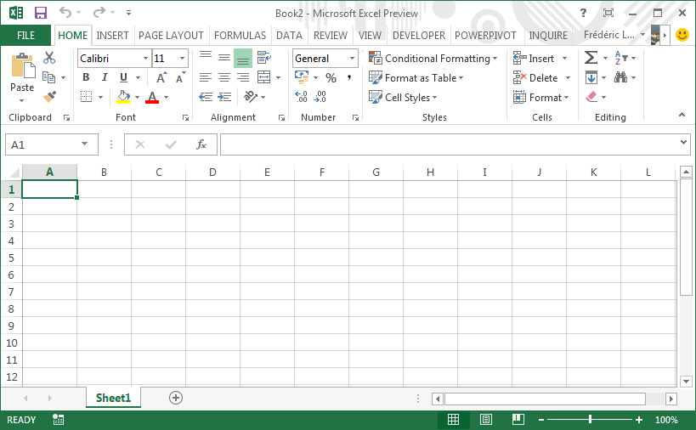
- Title bar / contains name of document
- Tabs
- Ribbon
- Section / Group
- Formula bar
- Name Box / tells location of cursor
- Column Headings / shows column
- Sheet of Excel / used for writing, work
- Active cell indicator / Pointer shows
- Row Headings / Shows row’s heading
- Vertical Scroll-bar / Moves vertically
- Scroll-up arrow / Moves up document
- To close current document / Closing
- User
- Caption buttons / Control box
- Tab scroll buttons / moving tabs
- Sheet tabs / every one is separate sheet.
- Area for sheets / to insert more sheets
- Status bar / Shows document property
- Horizontal scroll bar / view document
- Zoom

21

20
18

17

16

19

13

.xlsx
NAME BOX: The Name Box Shows the Address of Current / Selected Cell…
The Cell Address is a Combination of Column (C) and Row (16)…

FORMULA BAR: The Formula Bar Shows the Formula and Text of Current / Selected Cell…

SCROLL BARS: Placed at the right and bottom borders of the Worksheet window scroll bars Facilitate Moving around a Document using the mouse by dragging the scroll box along the scroll…

HORIZONTAL SCROLL BAR: Moves the Page rightward and leftward…

VERTICAL SCROLL BAR: Moves the Page upward and downward…

SHEET TABS: Sheet Tabs Shows All Sheets in Current Workbook…

STATUS BAR: Located at the bottom of the application window the status bar displays status or information about current Selection & about Worksheet…

FORMULAS / FUNCTIONS
In MS-Excel, We can Enter Numbers and Mathematical formulas into cells. When a number is entered into a cell, we can perform mathematical calculations such as addition, subtraction, multiplication, and division etc…
Note: Be Careful, Precede the Formula / Function with an Equal “=” Sign …

Difference between Formulas and Functions
Formulas: -
Mathematical Operators are used in Formulas like (“+” , “-“ , “*” , “/”)…
Functions: -
In Functions we Supply the Particular Function Name like =Sum(A1:A3)…

Reference Operators: -
There are Two Types of referencing…
- Range (Where we give just One Range Referencing)
- Union (Where we give Multiple Range Referencing)

How to Use a Function…
  - Use an Equal Sign to Begin a Formula…
  - Specify the Function Name…
  - Use Parentheses for Range Referencing…
  - Give Range in Parentheses…
  - Use Comma for Multiple Range Referencing…

Here is an Example of a Function…
=Sum(A1:A8,C13:C18)

ADDITION / SUM
There are Different Ways for Additions…
- Press “Alt and then =” keys…
- In Standard Toolbar, Click on “Auto Sum” Option…
- In Insert Menu, Click on “Function” Option…
- =Sum(A1:A5)
- =A1+A2+A3+A4+A5
- =12+89+23+32+98

SUBTRACTION / DIFFERENCE
There are 2 Ways for Subtraction…
- =A1-A2
- =10-4

DIVISION / QUOTIENT
There are 2 Ways for Division…
- =A1/A2
- =10/4

MULTIPLICATION / PRODUCT
There are Several Ways for Multiplication…
- =Product(A1:A5)
- =A1*A2*A3*A4*A5
- =3*2*29*12*9

POWER
There are 3 Ways for the Calculation of Power…
- =Power(A1,A2)
- =A1^A2
- =5^2 (Five Race to Power Two)

AVERAGE
There are 2 Ways for the Calculation of Average…
- =Average(A1:A10)
- =Total / Numbers

PERCENTAGE
=Obt Marks / Tot Marks * 100

COUNT
=Count(A1:A10)
Count Blank
=Countblank(A1:A10)

counta / count all
=Counta(A1:A10)

MAXIMUM
=Max(A1:A10)
MINIMUM
=Min(A1:A10)
CODE
=Code(“A”)
Character
=Char(65)
TABLE
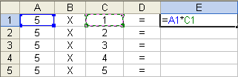

TIME
There are Several Ways for Time…
- Press “Ctrl + Shift + ;”…
- =Time(Hour,Minute,Second)
- =Hour(Cell Reference)
- =Minute(Cell Reference)
- =Second(Cell Reference)
- =Hour(Now())
- =Minute(Now())
- =Second(Now())

DatE
There are Several Ways for Date…
- Press “Ctrl + Shift + :”…
- =Date(Year,Month,Day)
- =Today()
- =Year(Cell Reference)
- =Month(Cell Reference)
- =Date(Cell Reference)
- =Year(Now())
- =Month(Now())
- =Date(Now())

DATE & TIME
=Now()

IF
There are Several Ways for “IF” Statement…
- =If(A1>=33, “Pass”, “Fail”)
- =If(A1>=33, “Pass”, If(A1<33, “Fail”))
- 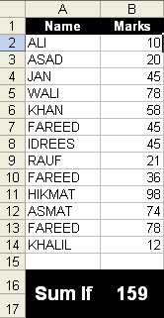=If(A1>=90, “A+”, If(A1>=85, “A”, If(A1>=80, “B”, If(A1>=75, “C”, If(A1<75, “Fail”)))))

SUM IF
=SumIf(A2:A14, “MHI”, B2:B14)

TRUE / FALSE

- =A1>A2 (True / False)

ROMAN
=Roman(34)

CHANGE CASE
=Upper(CELL REFERENCE)
=Upper(MUSLIM HANDS INFORMATICS)
=Lower(cell reference)
=Lower(syed fareed ahmed)
=Proper(Cell Reference)
=Proper(Muslim Hands Informatics)
TRIM
=Trim(Cell Reference) =Trim(“ Fareed ZF”)
File Menu
New (CTRL+N): It is used for the setup of New Workbook…
Open (CTRL+O): It is used to open a saved Workbook…
Close (CTRL+W): It is used to close the Current Workbook…
Save (CTRL+S): It is used to save Current Workbook…
Save As (F12): It is used for taking a copy of current Workbook. That Workbook will be saved with a different name & Location…
Save As Web Page (ALT+F+G): It is used to save the Workbook in a web page…
Web Page Preview (ALT+F+B): It is used to view Workbook before saving in a web page…
Save Workspace (ALT+F+W): It is used to save all the Opened Workbooks in one File (Resume) and it will also save each Workbook separately…
Note: If we are working on any Project so we have to work on Multiple Workbooks, so “Save Workspace” option will save all the Workbooks in the form of one File…
Search (ALT+F+H): It is used to Search any saved (MS-Office) File in your computer, Write File Name, select Location and then select file type, Click search And your wanted file has opened…
Page Setup (ALT+F+U): There are 4 Tabs in Page Setup Option…
- Page
- Margins
- Header n Footer
- Sheet
Page: - It is used to Choose (Paper, Orientation, Print Quality etc)…
Note: There are also 2 Options for Scaling in (Percentage & Pages wide by Pages)…
Margins: - It is used to Adjust Margins for Hard Copy and to Align Work in Center (Vertically & Horizontally)…
Sheet: - It is used to Choose the (Print Area, Print Options and Page Order) Options…
Print Area (ALT+F+T): It is used to Set & Clear Print Area which is the only Portion that will Printed…
Print Preview (ALT+F+V): It is used to look Worksheet before Printing…
Print (CTRL+P): It is used to print Whole Sheet or Selected Area on Paper…
Send to (ALT+F+D): It is used to mail or send Document to the Web or any one else…
Properties (ALT+F+I): It is used to View the Properties of current Workbook…
Recently Used Files (ALT+F+2): These are the files, which have used recently, and these can be opened easily…
Exit (ALT+F4): It is used to Exit the Current Application (Excel)…

Home Tab
Undo (CTRL+Z): It is used to Bring Back/Undo/Reverse the Last Action…
Redo (CTRL+Y): It Works Opposite to Undo Command …
Cut (CTRL+X): It is used to cut the selected Text or Data or Selection…
Copy (CTRL+C): It is used to Copy the selected Text or Data or Selection…
Paste (CTRL+V): After Cut/Copy Command we use Paste Option, To Paste Selection…
Note: After Cut or Copy Command Paste is Necessary…
Office Clipboard (CTRL+C+C): It is used for “Paste” Target, In Simple Cut/Copy Paste There we could Cut/Copy just one Selection/Objects and Then we Paste That, But in Office Clipboard Here we can Cut/Copy Multiple Selections and Then which one we want to Paste we will Just click on that in the Task Pane…
Paste Special (ALT+E+S): It is used to Paste any Selection Something Special…
Like as an Object, Formatted, Unformatted and as a Picture etc…
Paste as Hyperlink (ALT+E+H): It is used to paste any text including link from where was Cuted/Copied…
Fill (ALT+E+I): There are 7 Options in Fill Menu…
- Down
- Right
- Up
- Left
- Across Worksheet
- Series
- Justify
Down: - It is used to Fill Down the Cells from Top to Bottom…
Right: - It is used to Fill Right the Cells from Left to Right…
Up: - It is used to Fill Up the Cells from Bottom to Top…
Left: - It is used to Fill Left the Cells from Right to Left…
Across Worksheet: - It is used to Copy one Sheet’s Data into Other Sheets…
Series: - It is used to Fill Series in Linear, Growth & Date form…
Justify: - It is used to Justify / Distribute Context of Cells to Fill in Selected Range…
Note: Numbers and Formulas Can not be Justified…
Clear (ALT+E+A): It is used to Clear Formats, Contents or Comments of Selected Area…
Delete (CTRL+MINUS): It is used to Delete Cell, Row or Column…
Delete Sheet (ALT+E+L): It is used to Delete the Active Sheet…
Move / Copy Sheet (ALT+E+M): It is used to Create a Copy or to Move Current Worksheet to Another Workbook or to a Different Location in the Same Workbook…
Find (CTRL+F): It is used to find any Value/Formula/Comment in Current Worksheet or in Active Workbook…
Replace (CTRL+H): It is used to replace any Value/Formula/Comment in Active Worksheet or in Active Workbook…
First of all we have to give the Criteria and then we have to write the Replacement…
Go To (CTRL+G): It is used to Go/Switch to any Cell / Text Box…
Links (ALT+E+K): These options are used with “OBJECT” in Insert Menu
Object (ALT+E+O): ObjectCreate from fileLink to file…
Links: Here we can Update Link (F9), Open Source (Open Linked File), Change Source (To change with another File), Break Link and some other Update Link Options are there…
Object: Here we can Edit Link (To Edit in its Own Application), Open Link (To Open in its Own Application) and also Convert it into Icon…

Format
Cells (CTRL+1): There are 6 Tabs in Cells Option…
- Number
- Alignment
- Font
- Border
- Patterns
- Protection
Number: - It is used to Choose the Data Type for Current Selection of Cells like (Number, Currency, Text, Date & Time etc)…
Alignment: - It is used to Choose Text Alignment, Orientation & Direction in Selected Cells…
Font: - Using Font Tab we can apply and Edit Font (Face, Style, Size, Color, Underline Styles and Underline Color) and there are some other Effects for Font like: - Sub / Super Scripts and Strikethrough etc…
Border: - It is used to Edit Border Style & Color of Selected Cells…
Patterns: - It is used to Apply any Color / Pattern on Background of Selected Cells…
Row (ALT+O+R): It is used to Edit / Adjust the Row Height and to Show or Hide any Row…
Column (ALT+O+C): It is used to Edit / Adjust the Column Width and to Show or Hide any Column…
Sheet (ALT+O+H): It is used to Customize Current Sheet’s (Name, Background Color, Background Image, Tab Color and to Show / Hide)…
Auto Format (ALT+O+A): It is used to Apply Built-in Formats on Selected Range…
Conditional Formatting (ALT+O+D): It is used to Apply Formats to Selected Cells that have any Specific Criteria / Condition based on Values or Formulas…
Style (ALT+O+S): It is used to Apply, Make, Edit a Style, and to used on Specific Selection…

Insert Tab
Pivot Table & Pivot Chart Report (ALT+D+P): It is used to Start “Pivot table and Pivot Chart” Wizard, which Guides us through creating or Modifying a Pivot Table or Pivot Chart Report…
We need “Pivot” for Analyses of Complex Data where we can show the Record easily in Understandable way…
We can make Tables and Charts very easily by “Pivot” option of a Data in few Seconds…
Header & Footer (ALT+V+H): It is used to put some Text/Object at the Top & Bottom of (Every) Page for Hardcopy…
Commonly Header is used for Organization’s Title, Page Numbering and Date & Time etc…
And Footer is used for Author’s Name etc…
Note: Header n Footer will appear on every Page Automatically, and that’s the Benefit…
Comments (ALT+V+C): It is used to Show/Hide the Comments…
This Option works after giving some Comments in Insert Menu…
Cells (CTRL+PLUS): It is used to Insert Cell, Row or Column…
Row (ALT+I+R): It is used to insert Row in Active Worksheet…
Column (ALT+I+C): It is used to insert Column in Active Worksheet…
Worksheet (ALT+I+W): It is used to insert Worksheet in Active Workbook…
Chart (ALT+I+H): It is used for Creating Chart (Chart is the Easiest way for Summarizing/Reporting Record which could be Understandable for anyone)…
Chart Option is most Useful in MS-Access, Because of Wizard Mode…
Note: We make Charts in Excel in Wizard Mode, Where we just need to Select Options for making Chart…
Symbol (ALT+I+S): It is used to insert some Special Characters/Symbols which are not available on the Keyboard…
Page Break (ALT+I+B): It is used to Break Sheet in 4 Parts (just for Printing)…
Page Breaking can be Multiple Times…
Note: We also can Remove Page Breaks using this Option…
Function (ALT+I+F): It is used to Insert / Use a Function…
Here we Apply Function from Easy way because we have just to Select Options, The Formula will Come automatically…
Name (ALT+I+N): There are 5 Options in Name Command…
- Define
- Paste
- Create
- Apply
Comment (ALT+I+M): It is used to give Suggestion or Information on any Error in Document from anyone can find the Error easily…
Pictures (ALT+I+P): There are 8 Options in Pictures Submenu…
- Clip Art
- From File
- From Scanner or Camera
- Organization Chart
- Auto Shapes
- Word Art
Clip Art (ALT+I+P+C): It is used to insert Clip Art (Cartoons) which are Built-in MS-Office…
From File (ALT+I+P+F): It is used to insert Picture from Computer or any other Source…
From Scanner or Camera (ALT+I+P+S): It is used to insert Picture from any Attached Scanner or Digital Camera…
Organization Chart (ALT+I+P+O): It is used to insert a Chart for the use of an Organization, Company and all Other Official or Personal Work where we need to describe/show all Members or things etc…
AutoShapes (ALT+I+P+A): It is used to insert an AutoShape in Document…
From This Option AutoShapes will be Showing in Toolbar…
Word Art (ALT+I+P+W): It is used to insert Word Art (Built-in Styles in MS-Office for Text)…
Word Art can be used for Heading etc where we need to Show the Text something special…
Diagram (ALT+I+G): It is used to insert Diagrams for Official or Personal Works where we need to Describe/Show all the things etc Orderly…
In Diagram we have these Styles (Organization Chart, Cycle Diagram, Radial Diagram, Pyramid Diagram, Venn Diagram and Target Diagram)…
Note: Each Diagram is used According to its Need/Necessity…
Object (ALT+I+O): There are 2 Options in Object…
- Create New
- Create from File
Create New: - It is used to Work in Other Program using MS-Word like: - Paint, Corel Draw & Excel etc…
Create from File: - It is used to Include Data from any other file in Current Document…
Note: Difference between “File” and “Create from File” is that in Create from File we can Display file as Icon & also Link to file…
Hyperlink (CTRL+K): It is used for Making Link of Selected Text with (Another File, in Current Workbook & with E-mail etc)…
Formulas Tab
Define (CTRL+F3): - It is used to create a Name for a Cell or a Computed Value that we can refer to a Cell…
Paste: - It is used to Paste the Defined Cells Data in any Other Place of Worksheet / Workbook…
Create: - It is used to Create Names by Using Labels in a Selected Range…
When we Select that Particular Label from “Name Box” so all the Data of that Label will be Highlighted…
Apply: - It is used to Replace Cells with Defined Names, If Defined Names are made…
It is just used with any Formula where we give Cell Address, so Apply will Replace Cell Address with Defined names…
Label: - It is used to Apply Text Labels in Formulas, Means we can Sum the entire Label in a Cell by Giving the Label Name not Cell Address…

Formula Auditing (ALT+T+U): All the Options are there in “Formula Auditing Toolbar”…
Error Checking: - It is used to Check Errors in Formulas as we Studied in the Start of Tool Menu…
Trace Precedents: - It is used to Draw Trace Arrows from the Cells that Supplies Values Directly to the Formula in the Active Cell (Formula Having Cell)…
Usually it is used to view the Cells which have been used in Formula…
Note: There should be selected “Formula Having” Cell to show the Arrows with whom the link is…
Remove Precedent Arrows: - It is used to Remove all the Trace Arrows…
Note: There should be selected “Formula Having” Cell…
Trace Dependents: - It is used to Draw Trace Arrows to the Active Cell from Formula that Depend on the Value in the Active Cell…
Usually it is used to view the Formulas in which the Current Cell has been used…
Note: There should be selected “Value Having” Cell, which is used in Formulas…
Remove Dependent Arrows: - It is used to Remove all the Trace Arrows…
Note: There should be selected “Value Having” Cell, which is used in Formulas…
Remove all Arrows: - It is used to Remove all Arrows which have Traced in Worksheet…

Data Tab
Trace Error: - It is used to Trace the Error in Formula from the Cells that Causes the Error Value…
It is used to Check the Error that from which cells this Error is coming…
Note: “Error Having” Cell should be Selected for this Option…
Circle Invalid Data: - It is used to Show / Hide the Cells where Invalid Data has
Clear Validation Circles: - Entered, Validation is in Data Menu…
Evaluate Formula: - It is used to Check Formula that in which Section Error is there…
Goal Seek (ALT+T+G): It is used to Find or Search the Target by Changing the Value with another Cell Reference…
Usually we used it for Experiments that if I want 80% Marks so in English How many marks I need, So for this Purpose we used “Goal Seek” Option…
Scenarios (ALT+T+E): It is used to Create / Edit a Scenario or Set-up Which are sets of Data we can use to view the Results of What-if Analyses…

Auto Correct Option (ALT+T+A): Auto Correct Option has a list of Automatically Corrected Words and we also can add auto Corrects in Replace-with option, There are also some options for Correction…
Customize (ALT+T+C): It is used to Edit any Toolbar, to add a Toolbar and put Commands there, to Change the Place of any Command in any Menu or Toolbar, to Edit any Menu, to Add a Menu twice, to Add a Menu and Managed it by own and to change the Menu name and Command name and Picture etc…
So we can say that by Customize option we can control any Menu & Toolbar…
Options (ALT+T+O): It is used to Control all the Application’s Options…
Every Command which we want to Modify, we can that in Options…
Sort (ALT+D+S): It is used to Arrange the Data (Alphabetically, Numerically or by Date)…
Filter (ALT+D+F): There are 3 Options…
- Auto Filter
- Show All
- Advanced Filter
Auto Filter: - It is used to Filter out those Items which we want to Display in the List, Selecting Item in the Combo box…
Show All: - It is used to Show all the Rows / Records in the List…
It works Reverse of Auto Filter Option…
Advanced Filter: - It is used to Filter Data in the List by giving Condition or Criteria to Display the Record…
Note: The best way of using “Advanced Filter” option is by recording Macro and then applies that Macro on Criteria…
Forms (ALT+D+O): It is used to View our Data in the Form Shape…
Subtotals (ALT+D+B): It is used to Calculate Subtotal / Grand Total Values for the Labeled Columns we selected…
Validation (ALT+D+L): It is used to Valid / Restrict Area for Data Entry to a Particular Type, sucah as Whole Numbers, Decimal Numbers or Text etc. and Sets Limits on the Valid Entries…
Table (ALT+D+T): It is used to create a Table based on “Row Input Cell” and “Column Input Cell” Reference…
Table Option Can be used for making “Salary Table” where we need to Multiply the Salary with Total Days…
Text to Column (ALT+D+E): It is used to Convert / Exchange one Cell Text in to Multiple Columns…
Consolidate (ALT+D+N): It is used to Calculate Data from one or more Worksheets and to Calculate in one Cell…
Group & Outline (ALT+D+G): It is used to create Selected Rows or Columns of Detail Data as a Group in an Outline, so we can Summarize the Data easily…
Import External Data (ALT+D+D): It is used to Import Data from any Data Source / Database (MS-Access)…
Refresh Data (ALT+D+R): It is used to Refresh Data after Importing External Data and Editing that Data…

Review Tab
Spelling (F7): It is used to Check Grammatical & Spelling Mistake and Change into Correct word by selecting any Suggestion, Ignore, Add to Dictionary and by Auto correcting…
Error Checking (ALT+T+K): It is used to Check Errors in Formulas and to Evaluate that Formula by using some Steps…
Speech (ALT+T+H): It is used for (Voice Command, Dictation & Other Commands) used with Microphone…
Note: We also can Listen the Text in Cells by using “Text to Speech Toolbar”…
Share Workbook (ALT+T+R): It is used to Share Workbook on Network, Which Allows all the Users on Network to Edit and Save Changes in the Same Workbook…
Track Changes (ALT+T+T): By Track Changes each Insertion, Deletion & Formatting Changes will be shown in Comments to Prevent our Document from Mischief Source…
Accept or Reject Changes: It is used to Accept or Reject Changes which are made in Workbook…
Compare & Merge Documents (ALT+T+W): It is used to Compare the Difference between two Workbooks and to Merge two Workbooks Data…
Note: Usually it is used with Network Field when two Persons are working on Same Project so therefore they have to Compare & Merge their Documents…
Protection (ALT+T+P): There are 4 Options…
- Protect Sheet
- Allow Users to Edit Range
- Protect Workbook
- Protect Shared Workbook
Protect Sheet: - It is used to Prevent Access / Edition in Current Worksheet…
Allow Users to Edit Range: - It is used to Allow Users to Access / Edit the Specific Range, no to all the Sheet…
Protect Workbook: - It is used to Prevent Changes to the Structure of Current Workbook, So that Sheets Can’t be Deleted, Renamed, Hidden or Unhidden and New Sheet can’t be Inserted…
We also can Protect windows from being Moved, Resized or Closed…
Protect Shared Workbook: - It is used to Protect the Shared Workbook Option, So no one can Turn On/Off the “Share Workbook” Option…

View Tab
There are 2 Views (To View Our Document) in MS-Excel…
Normal (ALT+V+N): It is a Common Working view where we can see all the Cells of worksheet…
Page Break Preview (ALT+V+P): It is used to view only those Pages which have used, Other all the Worksheet will be Hide Except of Worked Cells…
Task Pane (ALT+V+K): It is used to Show/Hide the Task Pane (A Pane at the right side of the Screen)…
Formula Bar (ALT+V+F): It is used to Show/Hide the Formula Bar…
Custom Views (ALT+V+V): It is used to see Worksheet with Different Display Options…
Note: Usually it is used in Large amount of Data to Find out a Table / Record Easily…
Full Screen (ALT+V+U): It is used to View the Worksheet on Full Screen…
Zoom (ALT+V+Z): It is used to Change the Document’s Zooming (How to view the work Larger, Smaller)…
Note: Zoom size is Just for Soft copy not for Print; Means Print will come According to Font size not to zoom size…
Macro (ALT+F8): Macros are used to save work in a Macro, now when we need that work so just by click we can get that work, Sometimes we need same lengthy work so many times so for this Purpose we can make Macro and then we can’t to do lengthy work so many times but we just need a click…
Record New Macro: - It is used to Record new Macro…
New Window (ALT+W+N): It is used for the Setup of a new Window of Active
Workbook…
Note: By New Window Option we can view Different Parts of our Workbook at the Same Time…
Arrange (ALT+W+A): It is used to arrange all opened Workbooks on the Screen (Tiled, Horizontal, Vertical & Cascade) at the Same Time…
Note: “Arrange” Command makes it easier to Switch between opened Workbooks …
Hide (ALT+W+H): It is used to Hide the Active Workbook…
Unhide (ALT+W+U): It is used to Unhide the Active Workbook…
Split (ALT+W+S): It is used to Split / Divide Active Window into two Parts / Panes…
Note: If we are working on a Spreadsheet and we need to write Text from upper section of worksheet so for this Purpose we have to “Split” Window and then we can see Upper Section and Down Section at the same time on screen and can work on it…
Freeze Panes (ALT+W+S): It is used to Freeze a Range which we want to view Everywhere in Worksheet while Scrolling through a Worksheet…
Freezing Headings on a Worksheet doesn’t Effect Printing…

Help
MS-Excel Help (F1): It is used to get help about Microsoft Excel…
Show the Office Assistant (ALT+H+O): It is used to Show / Hide Office Assistant to Provide us help…
MS-Office Online (ALT+H+M): It is used to get help about Microsoft Office on Online Web…
Check for Updates (ALT+H+K): It is used to Check Updates about Microsoft Office…
Detect And Repair (ALT+H+R): It is used to Repair Microsoft Office if any Command or Tool is not working Properly, we can Repair MS-Office after Inserting Office CD in CD ROM and then “Detect & Repair” Option…
Activate Product (ALT+H+V): It is used to Registered MS-Office…
About MS-Excel (ALT+H+A): It is used to View the (Version, Copyright, Legal Licensing Notices, User & Organization Name, Serial Number and Information about Operating System) which has been using…

Microsoft Power Point
Microsoft power point is a presentation program, which is used for creating and editing a presentation that contains a combination of slides on which text, numbers, graphics (pictures & charts) are designed and used for displaying in a specific order to the audience.

- Microsoft Word is part of the Microsoft Office suite of applications, and thus shares additional features with Word, that is also part of the Office suite. It is used to Create Effective Slide Show Presentations…

- MS-Power Point is used for Reporting, Briefing & Analyzing the Project where we need to Show the Report on Slides using Projector…

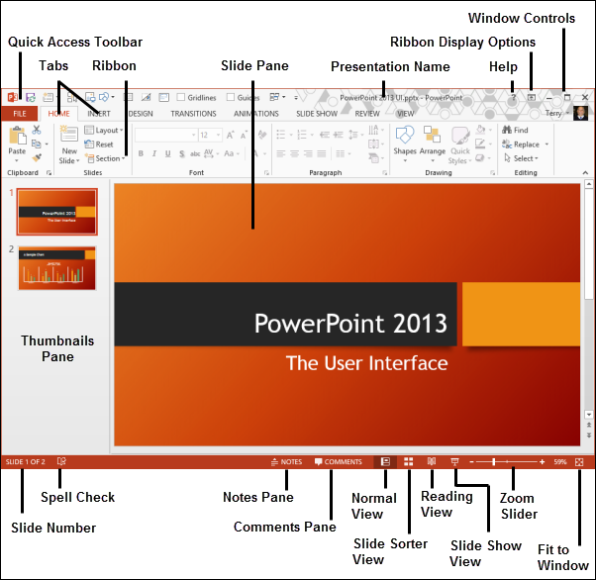
Interface of MS-Power Point

OUTLINES & SLIDES: It is used view Outlines (Text) or Thumbnail Pictures of all the Slides in Presentation…

RULER: Each document window has its own ruler that provides information about Indentation & Tabs for each Textbox…

SCROLL BARS: Placed at the right and bottom borders of the Presentation window scroll bars Facilitate Moving around a Document using the mouse by dragging the scroll box along the scroll…

HORIZONTAL SCROLL BAR: Moves the Page rightward and leftward…

VERTICAL SCROLL BAR: Moves the Page upward and downward…

PLACE HOLDERS: It Holds the Objects in Slide; Object can be in the form of Text, Picture and Chart etc…

STATUS BAR: Located at the bottom of the application window the status bar displays status or information about Slides & Presentation…
File Menu
New (CTRL+N): It is used for the setup of New Presentation…
Open (CTRL+O): It is used to open a saved Presentation…
Close (CTRL+W): It is used to close the Current Presentation…
Save (CTRL+S): It is used to save Current Presentation…
Save As (F12): It is used for taking a copy of current Presentation. That Presentation will be saved with a different name & Location…
Save As Web Page (ALT+F+G): It is used to save the Presentation in a web page…
Web Page Preview (ALT+F+B): It is used to view Presentation before saving in a web page…
Search (ALT+F+H): It is used to Search any saved (MS-Office) File in your computer, Write File Name, select Location and then select file type, Click search And your wanted file has opened…
Pack & Go (ALT+F+K): It is used to view the Presentation without MS-Power Point Installation, Means it is used to save the Presentation in such a file which don’t need any kind of MS-Office…
Most of Computers, we don’t see Office, so for such Computers we can make Pack & Go File…
Page Setup (ALT+F+U): It is used to adjust the page, To Choose the “Slide Size” for use and to choose the Orientation and “Number Slides from” options…
Page Setup is used to Setup Page for Soft copy & for Hard copy of Presentation…
Print Preview (CTRL+F2): It is used to look the Presentation before printing…
Print (CTRL+P): It is used to print the Slides on Paper…
Send to (ALT+F+D): It is used to mail or send Presentation to the Web or send to any other program like (MS-Word)…
Properties (ALT+F+I): It is used to View the Properties of current Presentation…
Recently Used Files (ALT+F+2): These are the files, which have used recently, and these can be opened easily…
Exit (ALT+F4): It is used to Exit the Current Application…

Home Tab
Undo (CTRL+Z): It is used to Bring Back/Undo/Reverse the Last Action…
Redo (CTRL+Y): It Works Opposite to Undo Command …
Cut (CTRL+X): It is used to cut the selected Text or Object…
Copy (CTRL+C): It is used to Copy the selected Text or Object…
Paste (CTRL+V): After Cut/Copy Command we use Paste Option, To Paste Selection…
Note: After Cut or Copy Command Paste is Necessary…
Office Clipboard (CTRL+C+C): It is used for “Paste” Target, In Simple Cut/Copy Paste There we could Cut/Copy just one Selection/Objects and Then we Paste That, But in Office Clipboard Here we can Cut/Copy Multiple Selections and Then which one we want to Paste we will Just click on that in the Task Pane…
Paste Special (ALT+E+S): It is used to Paste any Selection Something Special…
Like as an Object, Formatted, Unformatted and as a Picture etc…
Paste as Hyperlink (ALT+E+H): It is used to paste any text including link from where was Cuted/Copied…
Clear (Delete): It is used to delete the Selection / Object…
Select All (CTRL+A): It is used to Select All the Text/Objects in the Active Textbox…
Duplicate (CTRL+D): It is used to get the Duplicate copy of any Selected Object…
Delete Slide (ALT+E+D): It is used to Delete the Current Slide from Presentation…
Find (CTRL+F): It is used to find any Word in Active Slide…
Replace (CTRL+H): It is used to replace any Word in Slide…
First of all we have to give the Criteria and then we have to write the Replace word …

Format
Font (CTRL+O+F): It is used to Customize Font (Face, Style, Size & Color) and there are some other Effects for Font like: - Sub / Super Scripts and Shadow etc…
Bullets & Numbering (ALT+O+B): There are 2 Tabs in Bullets & Numbering…
- Bullets
- Numbers
Bullets: - It is used to apply and Edit the Bullets Style (In the Form of Character and Picture)…
Numbers: - It is used to apply and customize the Numbers Styles and Color…
Alignment (ALT+O+A): It is used to Change the Alignment of Current Paragraph…
Paragraph Direction (ALT+O+D): It is used to Change the Direction of Current Paragraph…
Line Spacing (ALT+O+S): It is used to Specify the Spacing between two Lines…
Change Case (Shift+F3): It is used to Change the Alphabet Case in order to (sentence case, lower case, UPPER CASE, Title Case & tOGGLE cASE)…
Replace Fonts (ALT+O+R): It is used to Change Font with another Font…
Slide Design (ALT+O+D): It is used to Choose any Theme (Template) for the Presentation…
We have some made Themes in MS-Power Point to Apply on any Presentation…
Note: In Color Scheme option we can Change the Color of Selected Theme…
Slide Layout (ALT+O+L): It is used to Apply / Change the Layout of Current Slide…
We have Different Layouts in MS-Power Point (Heading, Head and Body, Head and Two Sided Body and Tables and Charts etc)…
Background (ALT+O+K): It is used to Apply / Edit the Background Color of Slides in Presentation…
Object (ALT+O+O): It is used with any Object, when that is selected…
Note: It shows the Property/Format Window of any Object…

Insert Tab
New Slide (CTRL+M): It is used for taking new Slide on Current Presentation…
Duplicate Slide (ALT+I+D): It is used for taking a Duplicate Copy of Current Slide in Presentation…
Slide Number (ALT+I+U): It is used to Insert Slide Numbering…
Note: Slide Numbering will be set in Header and Footer Option…
Date and Time (ALT+I+T): It is used to Insert Date and Time…
Note: Date and Time will also be set in Header and Footer Option…
Symbol (ALT+I+S): It is used to insert some Special Characters/Symbols which are not available on the Keyboard…
Comment (ALT+I+M): It is used to give Suggestion or Information on any Error in Slide from anyone can find the Error easily…
Slides from Files (ALT+I+F): It is used to Insert Slides from another Presentation File…
Slides from Outline (ALT+I+L): It is used to Insert Slides from another Document File (MS-Word)…
Each Paragraph will come in its own Slide…
Pictures (ALT+I+P): There are 7 Options in Pictures Submenu…
- Clip Art
- From File
- From Scanner or Camera
- New Photo Album
- Organization Chart
- Auto Shapes
- Word Art
Clip Art (ALT+I+P+C): It is used to insert Clip Art (Cartoons) which are Built-in MS-Office…
From File (ALT+I+P+F): It is used to insert Picture from Computer or any other Source…
From Scanner or Camera (ALT+I+P+S): It is used to insert Picture from any Attached Scanner or Digital Camera…
New Photo Album (ALT+I+P+P): It is used to create new Photo Album where every Picture will be Fitted on Separate Slide…
Organization Chart (ALT+I+P+O): It is used to insert a Chart for the use of an Organization, Company and all Other Official or Personal Work where we need to describe/show all Members or things etc…
AutoShapes (ALT+I+P+A): It is used to insert an AutoShape in Current Slide…
From This Option AutoShapes will be Showing in Toolbar…
Header & Footer (ALT+V+H): It is used to put some Text/Object at the Top & Bottom of (Every) Slide…
Commonly Header is used for Organization’s Title, Page Numbering and Date & Time etc…
And Footer is used for Author’s Name etc…
Note: Header n Footer will appear on every Slide Automatically, and that’s the Benefit…
Header n Footer can be given to Notes and Handouts Pages…
Links (ALT+E+K): These options are used with “OBJECT” in Insert Menu
Object (ALT+E+O): ObjectCreate from fileLink to file…
Links: Here we can Update Link (F9), Open Source (Open Linked File), Change Source (To change with another File), Break Link and some other Update Link Options are there…
Object: Here we can Edit Link (To Edit in its Own Application), Open Link (To Open in its Own Application) and also Convert it into Icon…
Word Art (ALT+I+P+W): It is used to insert Word Art (Built-in Styles in MS-Office for Text)…
Word Art can be used for Heading etc where we need to Show the Text something special…
Diagram (ALT+I+G): It is used to insert Diagrams for Official or Personal Works where we need to Describe/Show all the things etc Orderly…
In Diagram we have these Styles (Organization Chart, Cycle Diagram, Radial Diagram, Pyramid Diagram, Venn Diagram and Target Diagram)…
Note: Each Diagram is used According to its Need/Necessity…
Text Box (ALT+I+X): It is used to insert Text Box anywhere in Slide…
If we want to write something upon the Picture or Drawing so we can write using Text box…
Movies and Sounds (ALT+I+V): It is used to insert any kind of Movie or Sound from Clip Organizer or from File or by Recording, in Current Slide…
Chart (ALT+I+H): It is used for Creating Chart (Chart is the Easiest way for Summarizing/Reporting Record which could be Understandable for anyone)…
Table (ALT+I+B): It is used for Creating Table, to put Data on a Specific Structure…
Object (ALT+I+O): There are 2 Options in Object…
- Create New
- Create from File
Create New: - It is used to Work in Other Program using MS-Power Point like: - Paint, Corel Draw & Excel etc…
Create from File: - It is used to Include Data from any other file in Current Presentation…
Note: Difference between “File” and “Create from File” is that in Create from File we can Display file as Icon & also Link to file…
Hyperlink (CTRL+K): It is used for Making Link of Selected Text with (Another File, in Current Document & with E-mail etc)…

Draw (ALT+R): There are Approximately 13 Options in Draw Tool…

Group (ALT+R+G): It is used to Group or Combine Multiple Objects as one Object…
Ungroup (ALT+R+U): It is used to ungroup all the Grouped Objects…
Regroup (ALT+R+O): It is used to Regroup or Recombine the Ungrouped Objects…
Note: It works Opposite to Ungroup Command…
Order (ALT+R+R): These Options are used for the Setting of Objects that which Object would be in front and which one would be behind…
Grid (ALT+R+I): It is used to Display Gridlines on Screen…
Using Grid Settings we give size in Inches & in Gridlines we give size in Centimeters…
Nudge (ALT+R+N): It is used to move any Object (if Picture so Text Wrapping is must) in all Directions (Up, Down, Right, Left)…
Align & Distribute (ALT+R+A): It is used to Align Objects (Left, Right, Center, Top, Middle and Bottom) and to Distribute Objects Horizontally & Vertically (Relative to Page or Objects)…
Rotate and Flip (ALT+R+P): It is used to Rotate and Flip Objects/Pictures…
Edit Points (ALT+R+E): It is used for making Connectors by Editing Points of a line or Arrow…
Change AutoShape (ALT+R+C): It is used to replace an AutoShape…
AutoShapes (ALT+U): It is used to insert an AutoShape in Slide…
Text Box: It is used to insert Text Box anywhere in Current Slide…
If we want to write something upon the Picture or Drawing so we can write using Text box…
Word Art: It is used to insert Word Art (Built-in Styles in MS-Office for Text)…
Word Art can be used for Heading etc where we need to Show the Text something special…
Diagram: It is used to insert Diagrams for Official or Personal Works where we need to Describe/Show all the things etc Orderly…
In Diagram we have these Styles (Organization Chart, Cycle Diagram, Radial Diagram, Pyramid Diagram, Venn Diagram and Target Diagram)…
Note: Each Diagram is used According to its Need/Necessity…
Fill Color: It is used to fill any (Color, Gradient, Texture or Pattern etc) in any Object…
Line Color: It is used to give Outline (In Color, Pattern) to any Object…
Font Color: It is used to Change the Font Color…
Line Style: It is used to give Line Style to any Object/Picture etc…
Dash Style: It is used to give Dash Style to any Object/Picture etc…
Note: There is little Difference between Line & Dash that Line doesn’t have any Break but in Dash there are Breaks between Dashes…
Arrow Style: It is used to apply an Arrow Style on a Selected Arrow…
Shadow Style: It is used to apply and edit a Shadow Style for the Current Word Art, Arrow or any other Object etc…
3-D Style: It is used to apply and edit 3-D Style (Effect) for any Word Art, Rectangle or any other Object etc…
Note: 3-D means “Three Sides” of any Object, so using 3-D we can see any Three Sides of Objects…

REVIEW Tab
Spelling (F7): It is used to Check Spelling Mistake and Change into Correct word by selecting any Suggestion, Ignore, Add to Dictionary and by Auto correcting…
Language (ALT+T+L): It is used to Set Languages to use in MS-Power Point...
Note: Language Keyboard Software of that Language must be installed to use that Language…
Speech (ALT+T+H): It is used for (Voice Command, Dictation & Other Commands) used with Microphone…
Note: There is also a Tool to work with as a Pencil, Usually we can use that for Signatures…
Compare & Merge Documents (ALT+T+P): It is used to Compare the Difference between two Presentations and to Merge two Presentation’s Data…
Note: Usually it is used with Network Field when two Persons are working on Same Project so therefore they have to Compare & Merge their Presentations…
Auto Correct Option (ALT+T+A): Auto Correct Option has a list of Automatically Corrected Words and we also can add auto Corrects in Replace-with option, There are also some options for Correction…
Customize (ALT+T+C): It is used to Edit any Toolbar, to add a Toolbar and put Commands there, to Change the Place of any Command in any Menu or Toolbar, to Edit any Menu, to Add a Menu twice, to Add a Menu and Managed it by own and to change the Menu name and Command name and Picture etc…
So we can say that by Customize option we can control any Menu & Toolbar…
Options (ALT+T+O): It is used to Control all the Application’s Options…
Every Command which we want to Modify, we can that in “Options”…
View Tab
There are Approximately 4 Views (To View the Slides) in MS-Power Point…
Normal (ALT+V+N): It is a Common Slides view where we can see all the Slides on “Fit to Screen”…
It is the Most Common & Useful View for Presentations…
Slide Sorter View (ALT+V+D): It is used to view the Presentation’s Slides as Thumbnail Pictures…
Slide Show (F5): It is used to View the Presentation on Full Screen…
It is used to Develop the Presentation…
Notes Page (ALT+V+P): It is used to View the Slides and Notes both on the Screen…
Every Slide can Contain Notes, so in other Views we can’t see all the Notes about Slides without “Notes Page” View…
Master (ALT+V+M): It is used to Edit the Slide’s Different Portions like: - The Header n Footer Area etc, It is a Master Slide Editing view…
There are 3 Options in Master Editing View.
- Slide Master
- Handout Master
- Notes Master
Slide Master: - It is used to Edit the Placement & Formatting of Different Parts of Slides (Header and Footer Area, Date and Time Area and Head & Body Area)…
Handout Master: - It is used to Edit the Placement & Formatting of Different Parts of Handouts & to Choose the Numbers of Slides on per Sheet…

What is Handout???
Handout is used for Printing options, To Print Some Slides with Blank lines to write out the Notes after Printing for every Slide…

How to Print Handout???
Handout’s Printing Options are there in “Print” to customize the Settings of Handouts and we also can see the Preview of Handouts in “Print Preview” Option…
Note: Usually “3 Slides per Sheet” option is used for Printing…
Notes Master: - It is used to Edit the Placement & Formatting of Different Parts of the Notes Page…
Color (ALT+V+C): It is used to switch the Colors to Grayscale or Colors…
Task Pane (ALT+V+K): It is used to Show/Hide the Task Pane (A Pane at the right side of the Screen)…
Ruler (ALT+V+R): It is used to Show/Hide Both Rulers (Hor,Ver)…
Ruler is used to Set Indentations, Tabs and for Putting Objects in same place on other Slides using Gridlines…
Grid & Guides (ALT+V+I): It is used to Display Grid and Guides on Slides to put any Object on same Place on every Slide…

What are Grid lines???
Grids are just like “Graph paper” in the Small Boxes Shape…

What are Guide lines???
Guides are Bigger than Grids, and by Default there are just 2 Guides (Hor,Ver) but if we want to Increase so we can by (Ctrl + Drag)…
View Direction (ALT+V+E): It is used to switch the view of Spirit bar (Thumbnail Pictures of Slides) Left to Right or Right to Left…
Markup (ALT+V+A): It is used to Show/Hide the Comments…
This Option works after giving some Comments in Insert Menu…
Note: In place of Markup, there could be “Comments” but both are same…
Zoom (ALT+V+Z): It is used to Change the Presentation’s Zooming (How to view the work Larger, Smaller)…
Note: Zoom size is Just for Soft copy not for Print; Means Print will come According to Font size not to zoom size…
Macro (ALT+F8): Macros are used to save work in a Macro, now when we need that work so just by click we can get that work, Sometimes we need same lengthy work so many times so for this Purpose we can make Macro and then we can’t to do lengthy work so many times but we just need a click…
Record New Macro: - It is used to Record new Macro…
New Window (ALT+W+N): It is used for the Setup of a new Window of Active Presentation…
Note: By New Window Option we can view Different Parts of our Presentation at the Same Time…
Arrange All (ALT+W+A): It is used to arrange all opened Presentations in Separate Windows on the Screen at the Same Time…
Note: “Arrange All” Command makes it easier to Switch between opened Presentations…
Cascade (ALT+W+C): It is used to arrange all opened Presentations in Cascade View…
Cascade is a Windows View…
Next Pane (F6): It is used to Switch between Different Portions of Slide…

Slide Show Tab
View Show (F5): It is used to View the Presentation on Full Screen…
It is used to Develop the Presentation…
Set up Show (ALT+D+S): It is used to customize the Slides Settings…
Here we have all the Option Settings for Slides…
Rehearse Timings (ALT+D+R): It is used to set Time for every Slide in Presentation for Slide Show view…
If we want view all the Slides in Presentation Automatically (not by Clicking), so for that Purpose we have to set Timing for every Slide that How a Slide would be shown in Slide Show…
Record Narration (ALT+D+N): It is used for Voice Commentary for Every Slide…
It is used to Define all the Components in Slide using Voice…
Action Buttons (ALT+D+I): It is used for the Setup of Buttons in Slides by giving Specific Link like: - (Home, Next Slide, Previous Slide, First Slide, Last Slide etc)…
Action Settings (ALT+D+A): It is used to Edit the Link given in Action Buttons in Different Form like: - (Hyperlink, Run Program, Run Macro, Object Action and Play Sound etc)…
Action Settings can be set on 2 Focuses (Mouse Click, Mouse Over)…
Note: Action Settings can be with any “Action Button” or with any “Object, Picture”…
Hide Slide (ALT+D+H): It is used to Hide / Show the Active Slide…
Custom Shows (ALT+D+W): It is used to set some Important Slides in Presentation Highlighted…

We seen 3 Options in MS-Office
MS-Word | MS-Excel | MS-Power Point
Bookmark | Custom View | Custom Show
These Three Options are same…
Animation Tab
Animation Scheme (ALT+D+C): It is used to apply Animation to all the Text in Slide…
Custom Animation (ALT+D+M): It is used to apply Animation to the Selected Text or Object…
It is used to make an Animation for Selected Text/Object yourself…
Note: The Animation of “Animation Scheme” and “Custom Animation” are Different…
Transition Tab
Slide Transition (ALT+D+T): It is used to apply Slide Transition on Selected Slide(s) in Presentation…
Slide Transition is an Effect that how our Slide should be Started…

Help
MS-Power Point Help (F1): It is used to get help about Microsoft Power Point…
Show The Office Assistant (ALT+H+O): It is used to Show / Hide Office Assistant to Provide us help…
What Is This? (Shift+F1): It is used to get help about command on click that Command…
Office On The Web (ALT+H+W): It is used to get help and Tutorial of MS-Office on Web…
Activate Product (ALT+H+V): It is used to Registered MS-Office…
Detect And Repair (ALT+H+R): It is used to Repair Microsoft Office if any Command or Tool is not working Properly, we can Repair MS-Office after Inserting Office CD in CD ROM and then “Detect & Repair” Option…
About MS-Power Point (ALT+H+A): It is used to View the Version and all the History of MS-Power Point which we are using…

Hardware Course Outline

- Introduction to Computer
- MS DOS
- Fdisk
- Format & Format Quick
- DM Seagate & DM without Seagate
- Copying Win98 In Hard Disk
- Win XP Installation
- Making Ghost
- Installation Of Ghost
- Ghost Making & Installation For Two Windows
- Different Kind Of Motherboard (Bios)
- Password & Password Braking (System Password, BIOS Password, XP Password)
- Driver Installation
  - Sound Driver
  - VGA Driver
  - Modem Drive
- How To Work Multimedia
- Assembling & Information about Components
- Trouble Shooting
- Partition with Win XP
- Removing Bad Socrates With DM2000
- System Restore In Win XP
- Magic Partition
- Nero CD Write and Making Image
- Making Bootable CD with Ultra ISO
- Deepfreeze
- Virtual PC
- Double Hard Disk and Double CD Rom.
- Windows 7 Installation
- Data Recovery With different software’s
- Introduction to Software

Computer
A computer is a programmable machine that receives input, stores and manipulates data, and provides output in a useful format, they can be constructed out of almost anything.

Or

Computer: A computer is an electronic machine that takes data as its input, processes the data and gives the information to the user as its output.
The word computer is derived from Latin word compute which means calculate.

The Fore Generations of Computers:
- The First Generation: 1946-1958 (The Vacuum Tube Years)
- The Second Generation: 1959-1964 (The Era of the Transistor)
- The Third Generation: 1965-1970 (Integrated Circuits - Miniaturizing the Computer)
- The Fourth Generation: 1971-Today (The Microprocessor)

Kinds of Computer:
There are Four kinds of Computer.
- Super Computer.
- Main Frame computer
- Mini computer
- Micro computer

Data: Data is the collection of raw facts and figures e.g.
Text (Alphabets, special characters, Numbers etc)
Images
Sound etc

Information: Information is the processed form of data, or we can say that it is the useful work done by the computer for its user.
Processing:The conversion of data into information by applying different types of calculations is called processing
Input: It is the data we give to the computer
Output: It is the useful information given to the user
Storage: It is the place inside the computer, where data is kept temporarily or permanently. We can write into and read from the storage

Components of a Computer:

There are 2 major components of a computer
Computer
Software

Hardware

Software: Software is the set of Instructions/Programs that are used to operate the computer.

Hardware:
The physically existing components of the computer are called hardware, or we can say that the tangible parts of the computers are hardware.

Hardware
The term hardware covers all of those parts of a computer that are tangible objects. Circuits, displays, power supplies, cables, keyboards, printers and mice are all hardware.

OR
The touchable parts or the part which has specific shape are called hardware.
There are some main parts of computer which are explained.
- Hardware
- RAM
- Processor

Definition of Hard Disk (HDD).
It is a storage device which stores data permanently are called hard disk.

Definition of RAM: (Random Access Memory):
It is also storage device but this device stores data temporary.
There are two types of RAM

SD RAM (Synchronous dynamic random access memory)

SD RAM was used first it was in old technology. It is open used in P(1), P(II) and in P(III). It has two notches in it which need that there must be two slots in motherboard. This RAM is slow than DDR RAM.

DDR RAM (Double data rate synchronous dynamic random access memory)
DDR RAM is used now-days it is powerful than SD RAM. It is new technology and open used in P(IV) and in latest computers. It has one notch.

Definition of Processor.
It is the brain of Computer which processes the data. All the devises works with the help of processor. When we give any command to computer so processor forwards the command and make process on it.

Hardware
The hardware can be categorized according to their functions.
Hardware
Storage Devices
Input Devices
Processing Devices
Output Devices
Permanent Storage Devices
Temporary Storage Devices

Input Devices
The devices through which, we give input to the computer are called input devices e.g.
Keyboard
Mouse
Scanner
Microphone etc.

Output Devices
The devices through which the computer gives the information to its users are called output devices e.g.
Monitor
Printer
Speakers etc.

Processing Devices
The devices that actually perform different kinds of operations on the data are called processing devices e.g.
CPU (Central Processing Unit, that performs the arithmetic and logical operations)
Motherboard (Mobo) (It is the associated device for the CPU that provides the interconnectivity among CPU and other devices)

Storage Devices
The devices that are used to hold data temporarily or permanently are called storage devices. We divide them into two major categories
Temporary Storage Devices: These devices hold the data as long as the computer is ON. Examples include RAM (Random Access Memory), Cache Memory etc. Temporary storage devices are often called Primary Storage Devices.
Permanent Storage Devices: The devices that retain their data contents even in the absence of electricity are called permanent storage devices. Examples include ROM (Read Only Memory), Hard-Disk, Floppy Disk, CD-ROM, Magnetic Tapes, Flash Memories etc. Permanent storage devices are often called Secondary Storage Devices.

Difference between Primary & Secondary Storage Devices

Primary Storage | Secondary Storage
Volatile | Non-Volatile
Fast | Slow
Expensive | Cheap
Low capacity | Large capacity

RAM
RAM (random access memory) is the place in a computer where the operating system, application programs, and data in current use are kept so that they can be quickly reached by the computer's processor. RAM is much faster to read from and write to than the other kinds of storage in a computer, the hard disk, floppy disk, and CD-ROM. However, the data in RAM stays there only as long as your computer is running. When you turn the computer off, RAM loses its data. When you turn your computer on again, your operating system and other files are once again loaded into RAM, usually from your hard disk.

Central processing unit (CPU)
The central processing unit (CPU) is the portion of a computer system that carries out the instructions of a computer program, and is the primary element carrying out the computer's functions. The central processing unit carries out each instruction of the program in sequence, to perform the basic arithmetical, logical, and input/output operations of the system. This term has been in use in the computer industry at least since the early 1960s. The form, design and implementation of CPUs have changed dramatically since the earliest examples, but their fundamental operation remains much the same.

Function
A general purpose computer has four main components: the arithmetic logic unit (ALU), the control unit, the memory, and the input and output devices (collectively termed I/O). These parts are interconnected by busses, often made of groups of wires.
Inside each of these parts are thousands to trillions of small electrical circuits which can be turned off or on by means of an electronic switch. Each circuit represents a bit (binary digit) of information so that when the circuit is on it represents a "1", and when off it represents a "0" (in positive logic representation). The circuits are arranged in logic gates so that one or more of the circuits may control the state of one or more of the other circuits.
The control unit, ALU, registers, and basic I/O (and often other hardware closely linked with these) are collectively known as a central processing unit (CPU). Early CPUs were composed of many separate components but since the mid-1970s CPUs have typically been constructed on a single integrated circuit called a microprocessor.

Control unit
The control unit (often called a control system or central controller) manages the computer's various components; it reads and interprets (decodes) the program instructions, transforming them into a series of control signals which activate other parts of the computer.

Arithmetic/logic unit (ALU)
The ALU is capable of performing two classes of operations: arithmetic and logic.[26]
The set of arithmetic operations that a particular ALU supports may be limited to adding and subtracting or might include multiplying or dividing,
Logic operations involve Boolean logic: AND, OR, XOR and NOT. These can be useful both for creating complicated conditional statements and processing Boolean logic.

Memory
A computer's memory can be viewed as a list of cells into which numbers can be placed or read. Each cell has a numbered "address" and can store a single number. The computer can be instructed to "put the number 123 into the cell numbered 1357" or to "add the number that is in cell 1357 to the number that is in cell 2468 and put the answer into cell 1595". The information stored in memory may represent practically anything. Letters, numbers, even computer instructions can be placed into memory with equal ease. Since the CPU does not differentiate between different types of information, it is the software's responsibility to give significance to what the memory sees as nothing but a series of numbers.

Input/output (I/O)
I/O is the means by which a computer exchanges information with the outside world.[29] Devices that provide input or output to the computer are called peripherals.[30] On a typical personal computer, peripherals include input devices like the keyboard and mouse, and output devices such as the display and printer. Hard disk drives, floppy disk drives and optical disc drives serve as both input and output devices. Computer networking is another form of I/O.

CMOS
Complementary metal–oxide–semiconductor (CMOS) (pronounced /ˈsiːmɒs/) is a technology for constructing integrated circuits. CMOS technology is used in microprocessors, microcontrollers, static RAM, and other digital logic circuits. CMOS technology is also used for several analog circuits such as image sensors, data converters, and highly integrated transceivers for many types of communication. Frank Wanlass patented CMOS in 1967.

Computer Abbreviations
Computer = Commonly Operated Machine Particularly Used for Technological Engineering Research
Computer = Compile Optimize Manipulate Utilize Terminate End Process Rewritable

PC = Personal Computer

BIOS=Basic Input Output System

FDISK=Fixed Disk

DM=Disk Manager

DOS=Disk Operating System

CMD=Command Prompt

CD=Change Directory

DIR=Disk Information Report

MD=Make Directory

RD=Remove Directory

CLS=Clear Screen

FAT 32=File Allocation Table

NTFS=New Technology File System

CD-ROM =Compact disc read-only memory

DVD-ROM =Digital Video Disc read-only memory

CD-RW = Compact Disk – Rewritable

CD-R = Compact Disk – Recordable

FD = Floppy Disk

RAM = Random Access Memory

ROM = Read Only Memory

SIM = Single In Rate

DDR= Double Data Rate

CPU = Central Processing Unit

ALU=Arithmetic Logic Unit

CU = Control Unit

HDD = Hard Disk

USB = Universal Serial Bus

PCI = Peripheral Component Interconnect

VGA = Video Graphics Accelerator

POST = Power On Self Test

CMOS = Complementary Metal Oxide Semiconductor

IBM = International Business Machines Corporation
AGP slot = Accelerated Graphics Port
LPT Port = Local Printer Terminal (Printer Port)
PS2 or Mini Din: Personal System 2

Pentiums

Pentium One
100, 133, 166, 200, 233 (Socket)
Pentium Two
233 (Slot) 266, 300, 333 (Celeron), 366 (Original & Celaron), 400, 450, 466 (Celeron), 500
Pentium Three
450, 500, 550, 600, 667, 700, 750, 800, 866, 900, 933, 1.0, 1.1, 1.2, 1.3
Pentium Four
1.5, 1.6, 1.7, 1.8, 2.0, 2.2, 2.4, 2.6, 2.8, 3.0, 3.2, 3.4, 3.6 3.8
Core 2 duel
Core 2 cad
Core I 3,5,7

Bit (Binary Digit)
1 byte = 8 bit
1 kilobyte = 1024 byte
1 megabyte = 1024 Kbyte
1 gigabyte = 1024 mbyte
1 terabyte = 1024 gbyte

MS-DOS
Microsoft Disk Operating System
Microsoft Disk operating system, MS-DOS is a non-graphical command line operating system created for IBM compatible computers that was first introduced by Microsoft in August 1981 and was last updated in 1994 when MS-DOS 6.22 was released. Although the MS-DOS operating system is not commonly used today, the command shell used through Microsoft Windows is.
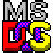

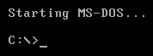

BASIC COMMANDS OF DOS:
To Change the Background and Foreground Color:
Color attributes are specified by TWO hex digits -- the first
corresponds to the background; the second the foreground. Each digit
can be any of the following values:
0 = Black 8 = Gray
1 = Blue 9 = Light Blue
2 = Green A = Light Green
3 = Aqua B = Light Aqua
4 = Red C = Light Red
5 = Purple D = Light Purple
6 = Yellow E = Light Yellow
7 = White F = Bright White

- CD (Change Directory) “ to change Folder or Directory”
Usage: - c:\>documents and settings\teacher> cd
c:\>documents and settings>

2) CD/ (To Go Full Back)
Usage: - c:\>documents and settings\teacher\desktop> cd/
c:\>

3) D: (Change Drive)
Usage: - c:\>documents and settings> d:
D:\>

4) DIR (Disk information report) “to view sub folders in current directory”
Usage: - c:\>documents and settings\teacher> DIR

- DIR/W (to view all files and folders width wise)
6) DIR/P (to view all files and folders page wise)
DIR/B - (Shows only the long filename, no details )
you can show and recall the history of commands you enter and the DOS prompt.
- To recall previous commands, use the up arrow key.
- A complete list of previous commands can be shown if you press the F7 key
- To use one, press F9 and the number of the command you want to use
- To clear the cache, press Alt+F7
d:/> exit (close dos)
7) Usage: - D:\>DIR/AH (To View all Hidden Files and Folders)
) Usage: - D:\>Attrib +s +r +h +a “Folder Name or File Name” (To Hide Files and Folders)
8) Usage: - D:\>Attrib -s -r –h -a “Folder Name or File Name” (To Show Hidden Files and Folders)

9) MD folder name (Make Directory)
D:\>MD Muslim Hands (Make two or more than two Folders at one time)
D:\>MD “Muslim Hands”
D:\>MD 1 2 3 4 5 6 7 8 9
D:\>RD 1 2 3 4 5 6 7 8 9
Usage: - D:\>MD MHI
D:\>ren MHI “Muslim Hands Informatics”

10) CD folder name (To open folder)
Usage: - D:\ >CD MHI
D:\MHI>

11) RD folder name (Remove Directory)
Usage: - D:\ >RD MHI
Or Usage: - D:\ >rmdir MHI
Usage: - D:\ >RD /S MHI (this command is removed the folder and contents)
Usage: - D:\ >RD /? /? This command is used for Help

12) DATE ( change date)

13) TIME (change time)

14) CLS (Clear Screen)

15) Usage: - D:\MHI> Erase *.* (Delete all files Except folders)
Or D:\MHI> Del *.*
D:\MHI>Del Ghost.exe (this will delete the singal file)
D:\Ghost2003>copy Ghost.exe E:\Ali (this will copy singal file from one director to another)
D:\>type ali.txt (It will show all texts on DOS)
D:\>Edit ali.txt (you should edit that file)
D:\>ali.txt
Note: First Write all Texts on notepade and save it any drive.
D:\>dir > ali.txt

16) Copying win98 from “G”to”D” drive:-
D:\>md windows98
D:\>cd windows 98
D:\ windows 98>
G:
G:\cd win98
G:\win98>copy ** d:
G:\win98>Format C:/S/q
To change the admin password we type
C:/>net user (It is used to show all users)
C:/>net user administrator *
Or
Open notepad and write this formula
Net user administrator 123
Pause.
And then save it and give the extension for example Hack.bat or Hack.cmd

Internet Course Out line

Browsers:
- Internet Explorer
- Fire Fox
- Opera
- Google Chrome

ID’s:
- Yahoo ID
- Gmail
- Hotmail
- Facebook

Messengers:
- Yahoo Messenger
- Google Talk
- Skype
- Meebo
- Ebuddy
- YahooDetector

Message to Mobile:
- www.textpk.com
- www.sms4smile .com

Result Education:
- www.bitqta.edu.pk
- www.hamaraquetta.com
- www.quettaresult.com

Online Games:
- www.friv.com
- http://www.y8.com/
- http://www.miniclip.com/games/en/

Torrent:
- www.torrentz.com
- www.extratorrent.com
- http://thepiratebay.se

Software’s:
- Internet download manager
- Google Earth
- Flash Player
- Team viewer

Downloading:
- www.filehippo.com
- download.com
- www.softarchive.net
- www.apphit.com
- www.brothersoft.com

YouTube:
- www.youtube.com
- Www.youtube.com/user/hazratalin

Photo Making Online:
- www.photofunia.com
- funny.pho.to

Weather:
- Today Quetta Weather search in Google

SIM Information:
- Search in Google 668
- http://www.hamaraquetta.com/

Watch News:
- Geo and newspaper Search on Google
- http://e.jang.com.pk/

Search Engine:
- www.google.com

Dictionary:
- http://translate.google.com/
- http://hamariweb.com/dictionaries/breed_urdu-meanings.aspx

Storing Data:
- www.4shared.com
- skydrive

Online Watch Movies:
- www.onlinewatchmovies.net
- www.movie2k.com
- http://entertainment.ptcl.net/

Online Check Bill:
- dbill.ptcl.net.pk/

Notes:
- http://itdunya.com/
- http://www.pakistanipoint.com/

Online MP3 songs:
- http://www.mastimela.net/music/new_songs.htm

Computer Components:
- http://galaxy.pk/
- http://www.czone.com.pk/

What is Internet?
Internet is a massive and worldwide network of computers that can communicate to each other.

The internet was driven by a command line interface, similar to Microsoft DOS.

The Internet evolved from APRANET, a lot 60’s project started by the US Dept of Defense. The ARPANET started as a link between UCLA and the Stanford research Institute, soon after a link to the University of Utah and UC Santa Barbara were added.

The Internet is “not” the same thing as the “World Wide Wed”.


What is the World Wide Web?
A special set of servers on the internet that are designed to send/receive specially formatted text documents (web pages) via HTTP, Hyper text Transfer protocol.

Most Documents on the World Wide Web are formatted in HTML. Hyper Text Markup Language.
HTML documents can contain text, images, and multimedia content.

Instead of a Command line interface, users interact with the pages on the World Wide Web in a Graphical User Interface through a Web Browser.

Web Browser
A Web Browser is a software program that lets you documents (web pages) access the world wide web.

The web Browser program translates the HTML documents so the end user sees formatted text, images, and multimedia content.

Examples of Web Browsers include:
- Microsoft Internet Explorer
http://www.microsoft.com/windows/ie/default.asp
- Netscape Navigator
http://www.channels.netscape.com/ns/browsers/default.jsp
- Mosilla
http://wwwmozilla.org
- Opera
http://opera.com
- Safari (Macintosh Only)
http://www.apple.com/safari
- Mosiac(the first widely known web browser)
http://archive.ncsa.uiuc.edu/SDG/Software/Masoic/NCSAMosaicHome.html
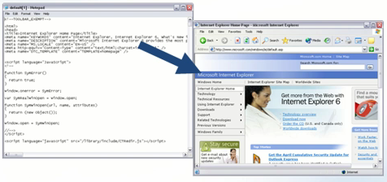

Electronic Mail
Electronic Mail (E-Mail) refers to a message sent from one computer to another.

E-Mail can contain text, images, and multimedia content.You can attach files, such as photographs and spreadsheets to e-mails too.

There are defferent types of e-mail accounts, such as POP, IMAP and Web Mail(HTTP).

Some E-mail accounts can be accessed on the Web while others require a separate software program.

E-Mail Programs
There are many E-mail programs available:
- Outlook Express
Installed with Windows(Internet Explorer) Automatically
- Outlook
Hhtp://office.microsoft.com/home/default.aspx
- Netscape Mail
Installed with Netscape Navigator Automatically
- Eudora
http://www.eudora.com
- Thunderbird
http://mozilla.org/products/thunderbird
- Mail(Macintosh)
Installed with Mac OS X Automatically
- Hotmail (Web)
http://www.hotmail.com
- Yahoo (Web)
http://www.yahoo.com

Instant Messaging
Instant Messaging lets you send electronic messages to other people online n real-time, referred to as “chatting”.

Instant Messaging is a great way to stay in touch with friends, co-workers, and family member.

Some Instant Messaging clients support voice and video chatting, which let you see and hear the person you are chatting with.

There are several Instant Messaging clients available:
- MSN Messenger
http://messenger.msn.com
- AOL Instant Messenger
http://www.ail.com
- Yahoo Instant essenger
http://messenger.yahoo.com
- ICQ
http://www.icq.com
- iChat (Macintosh)
http://www.apple.com/ichat

Newsgroups
Newsgroups are electronic message forums where you can read and post messages.

Some newsgroups are private, but most are public and accessible to anyone with access to the Internet.

Newsgroups are great for getting help with software programs, sharing pictures, discuss hobbies and other interests, and there is a newgroup for just about every topic imaginable.

To access a Newsgroup, you will need a software program, called a News Reader or News Client. Some Newsgroups can be accessed through a web page.]

Getting Connected
To get connected to the Internet you have to make first a connection by the following terms.
Note: There is difference account of getting connected to the internet
- Dialup Modem (Which can be used a lot around the country)
- Broadband (cable modem, DSL modem and high speed wireless connection)
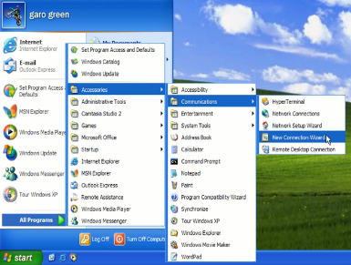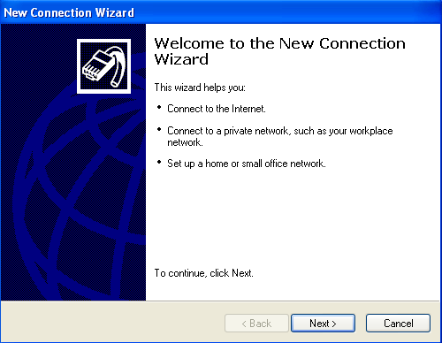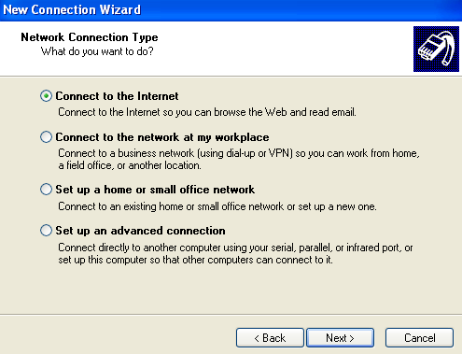

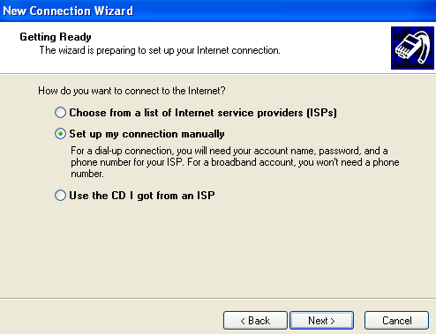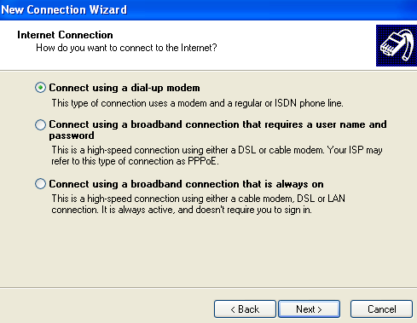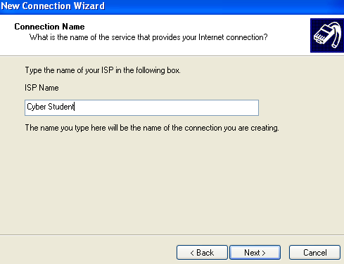

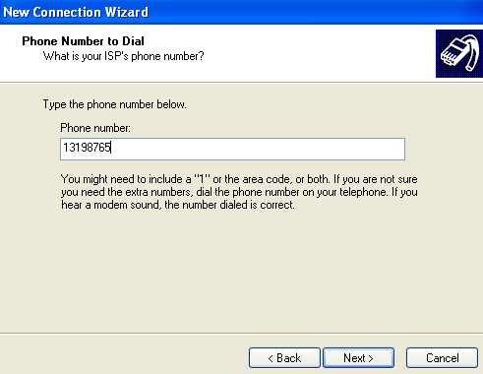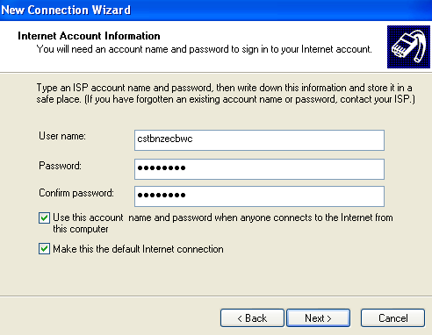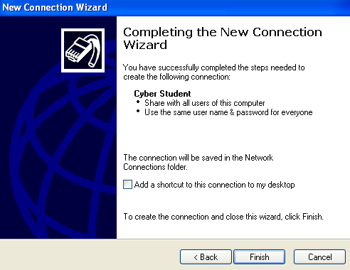

Internet Explorer 6
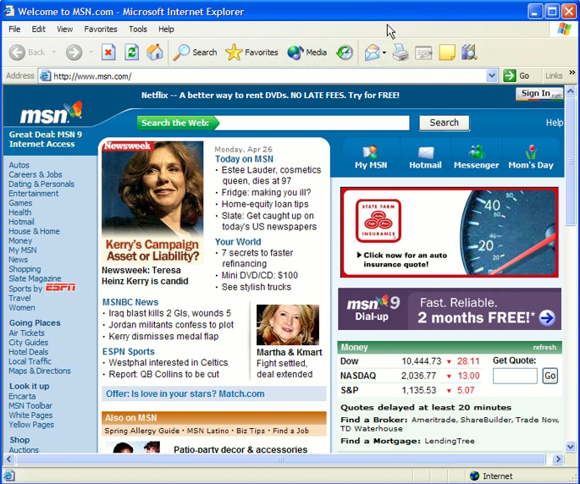
- Title Bar:
- Menu Bar:
- Caption Buttons:
- Standard tool bar:
- Address Bar: The Most Important Bar
- Linking Bar:
- Page Area:
- Vertical Scrolled Bar:
- Horizontal Scrolled Bar:
- Status Tool Bar:

http:// Hyper text transfer protocol is the header of any address.

Ftp: // is also header of any address.

WWW: it is a world wide web it gives access to open any webpage.

Inter net

Enter / To Work in Net or Jhal

Definition: -
Internet is a Massive & Worldwide Network of Computers which is used to communicate the Computer Systems…

Browsers: -
To Connect / Work with Internet we need a net Browser…
There R Several Browsers like
Internet Explorer (Built-in)
Mozilla Firefox
Opera
Google Chrome

Search Engine: -
If we want to search some information about anything and we don’t know the Specific Website so we can search that by a browser…
To Search something and want Several Websites about that Particular thing…
There R Several but Main Search Engines are
Google
Yahoo
Bing (Microsoft) / MSN

Abbreviations
HTTP : Hyper Text Transfer Protocol
FTP : File Transfer Protocol
SMTP : Simple Mail Transfer Protocol
IP : Internet Protocol.
TCP : Transmission Control Protocol
RJ45 : registered jack
UTP : Unshielded Twisted Pair
STP : Shielded Twisted Pair

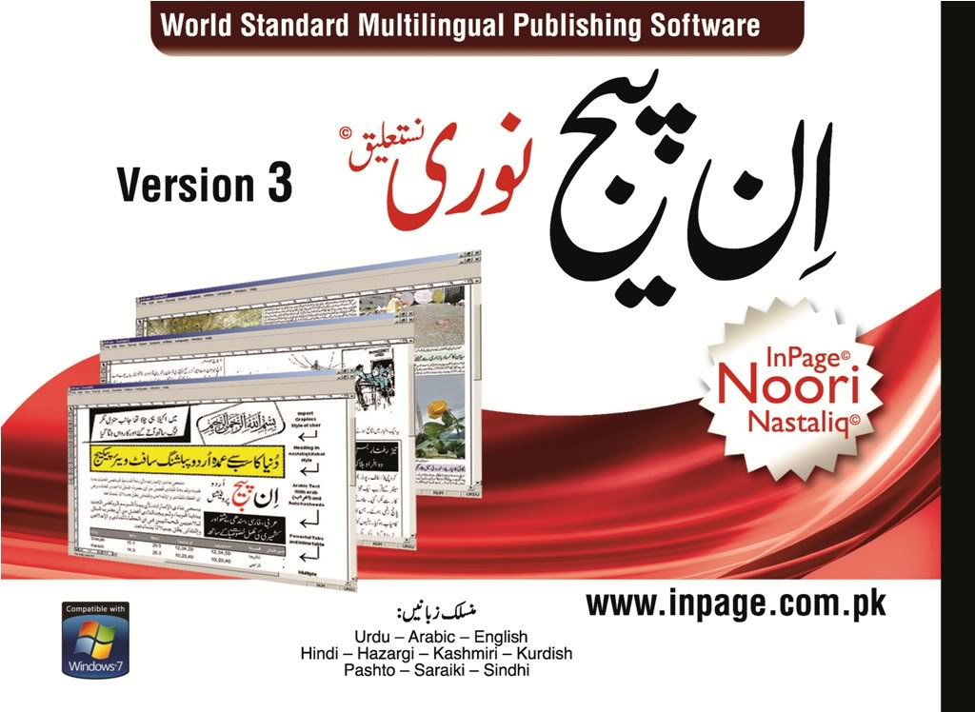
InPage
InPage is a word processor and page layout software for languages such as Urdu, Persian, Pashto and Arabic under Windows which was first developed in 1994. OR

InPage is a multi-lingual word processor. This software supports Urdu, Arabic, English Hazaragi, Kashmiri, Pushto, Persian and Sindhi languages. This software is developed by Software Paradise Pvt. Ltd and can be obtained from urdusoft.webjump.com. This software provides different keyboard layouts with supported alphabets. No special device is required to work with InPage. We can set the layout of the keyboard according to our requirements.
This software uses windows font for English writing while for other languages this software has its own fonts. These fonts are called Nastaliq fonts. This software works almost similar to MS-Word. We can create our document, columns and tables. We can insert images, draw boxes and create text boxes are well
Interface of InPage

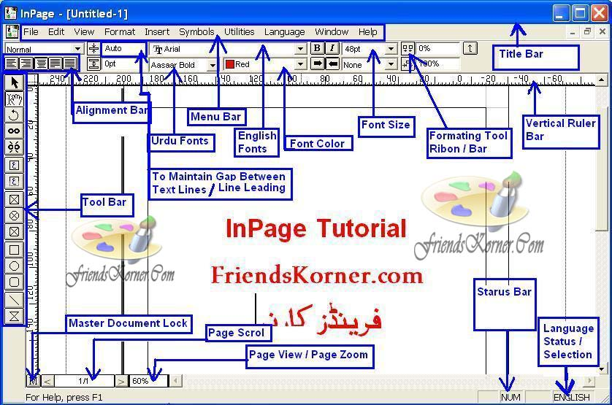
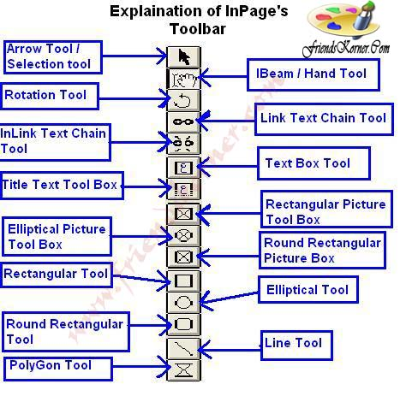
InPage Urdu Keyboard
